Date | Asset | Suggested Message for Social Media
11/10  *First day of Social Connection Awareness Week | 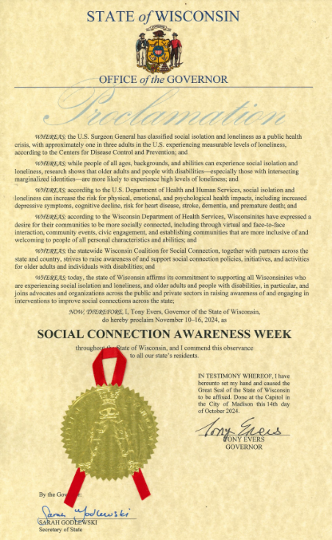 | November 10th – 16th is Social Connection Awareness Week in Wisconsin! Learn more at ConnectWI.org. #ConnectWI #BacktotheBasics #BuildingBlocksofConnection
11/11 | 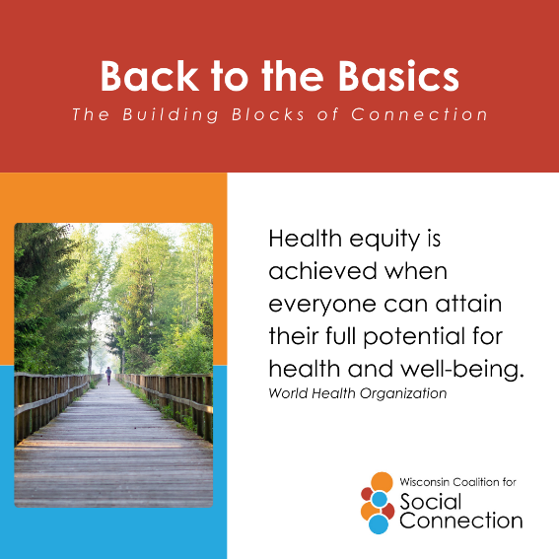 | Equity is a #BuildingBlockofConnection. Communities that promote equity can improve social connection for all populations. #ConnectWI #BacktotheBasics
11/11 | 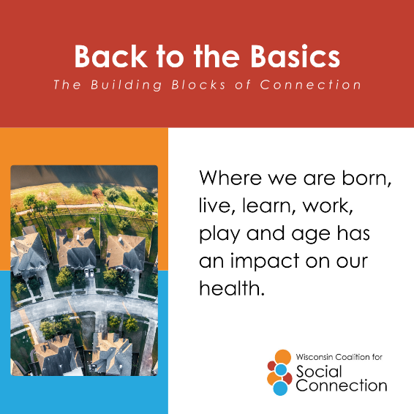 | From accessible community spaces to access to technology, there are many things we can do to ensure our communities offer opportunities for all. Both loneliness and social isolation are associated with serious health impacts including a 29% increased risk of heart disease a 32% increased risk of stroke, and a 50% increased risk of dementia as well as a significant increased risk for depression and anxiety. Learn more and join the movement at ConnectWI.org. #ConnectWI #BacktotheBasics #BuildingBlocksofConnection
11/11 | 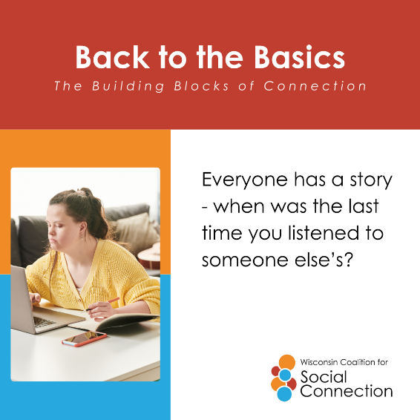 | No two people are exactly alike. Take time today to connect – really connect – with someone and have them tell you their story.  Learn more and join the movement at ConnectWI.org. #ConnectWI #BacktotheBasics #BuildingBlocksofConnection
11/12 | 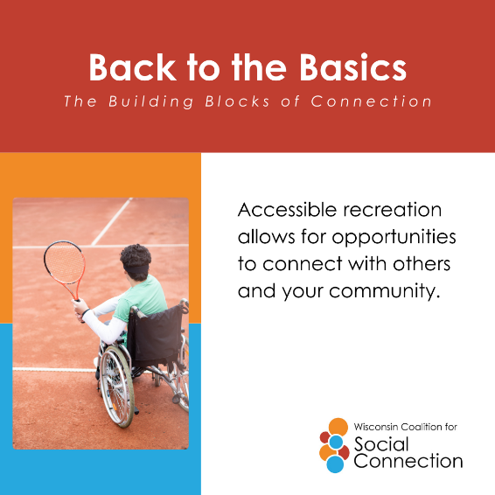 | Accessibility matters. Learn more and join the movement at ConnectWI.org. #ConnectWI #BacktotheBasics #BuildingBlocksofConnection
11/12 | 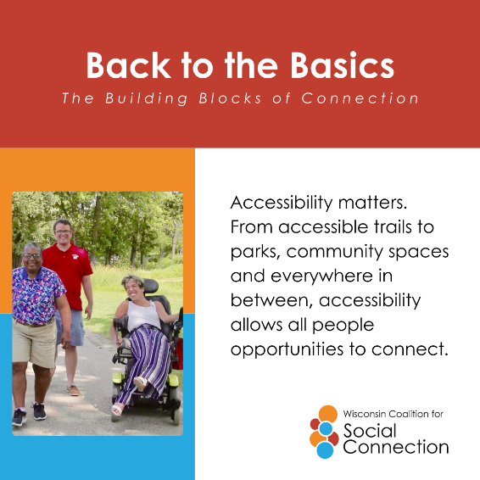 | Are there safe sidewalks or crosswalks in your community? Are the buildings where people gather ADA compliant? Is there adaptable equipment at the parks or beaches? Accessibility can pave the way for connection.  Learn more and join the movement at ConnectWI.org. #ConnectWI #BacktotheBasics #BuildingBlocksofConnection
11/12 | 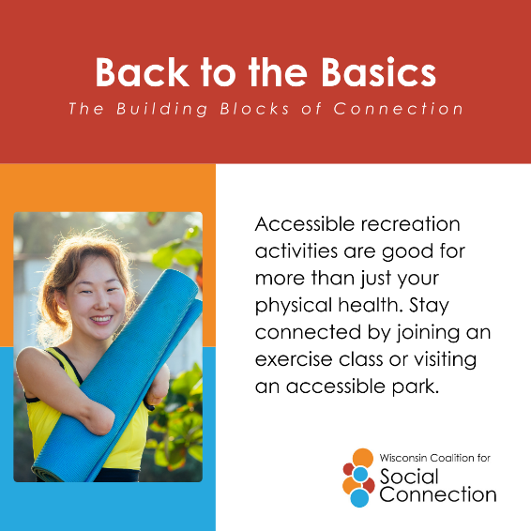 | Connect with others and improve both your social and physical health!  Learn more and join the movement at ConnectWI.org. #ConnectWI #BacktotheBasics #BuildingBlocksofConnection
11/13 | 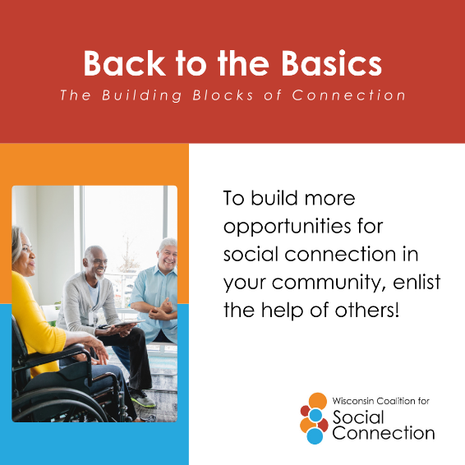 | Partnerships are one of the #BuildingBlocksofConnection. Reduce social isolation and loneliness by gathering with others towards a common cause!  Learn more and join the movement at ConnectWI.org. #ConnectWI #BacktotheBasics
11/13 | 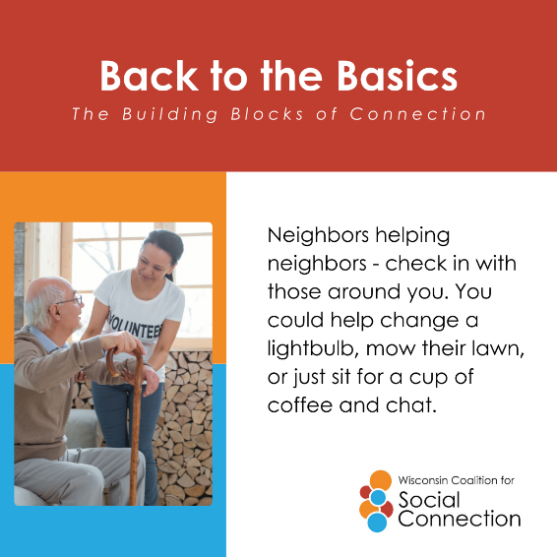 | Is there someone in your family or community who may be lonely or isolated? Go #BacktotheBasics – reach out, stay in touch!  Learn more and join the movement at ConnectWI.org. #ConnectWI #BuildingBlocksofConnection
11/13 | 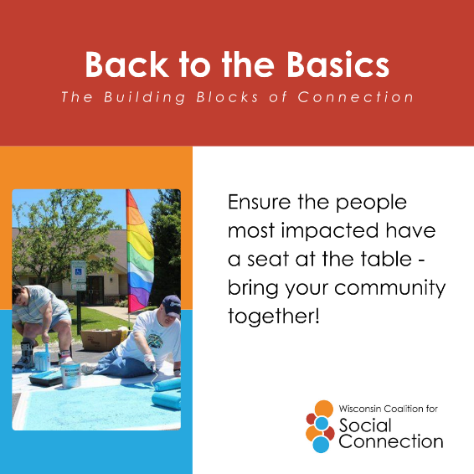 | Involved in a coalition or community group or looking to get one started? Be sure to include older adults and people with disabilities!  Learn more and join the movement at ConnectWI.org. #ConnectWI #BacktotheBasics #BuildingBlocksofConnection
11/14 | 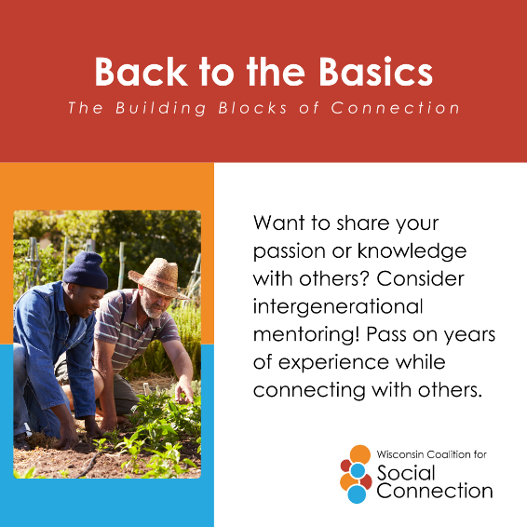 | Connecting with people from different generations is a proven way to reduce social isolation and loneliness.  Learn more and join the movement at ConnectWI.org. #ConnectWI #BacktotheBasics #BuildingBlocksofConnection
11/14 | 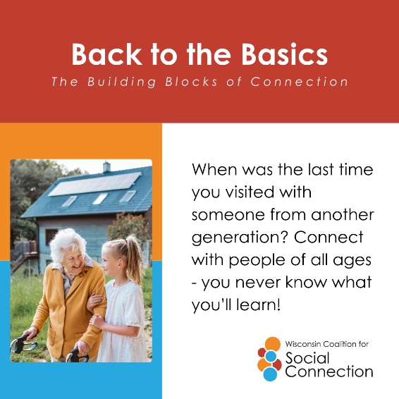 | Do you have time to share? You can make a big difference in someone’s life. Social connections that cross generations can be extremely valuable for all involved.  Learn more and join the movement at ConnectWI.org. #ConnectWI #BacktotheBasics #BuildingBlocksofConnection
11/14 | 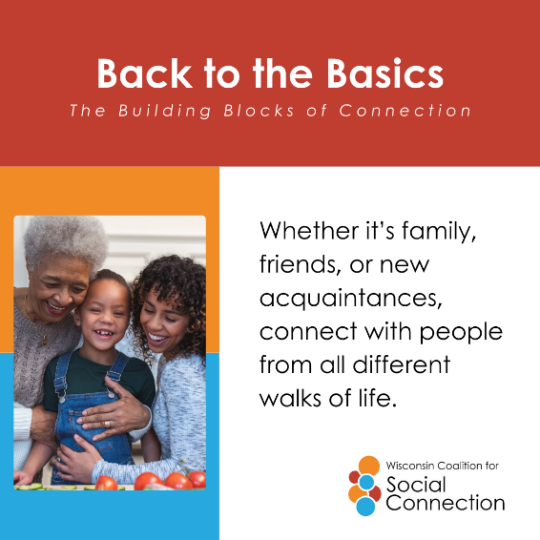 | Whether it’s family, neighbors, coworkers, or strangers, find people with common interests to connect with – no matter their age!  Learn more and join the movement at ConnectWI.org. #ConnectWI #BacktotheBasics #BuildingBlocksofConnection
11/15 | 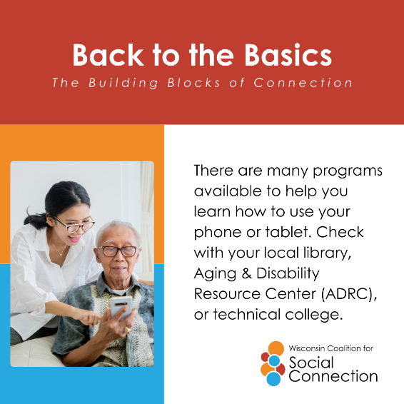 | Technology is a great way to stay connected when we can’t be face-to-face.  Learn more and join the movement at ConnectWI.org. #ConnectWI #BacktotheBasics #BuildingBlocksofConnection
11/15 | 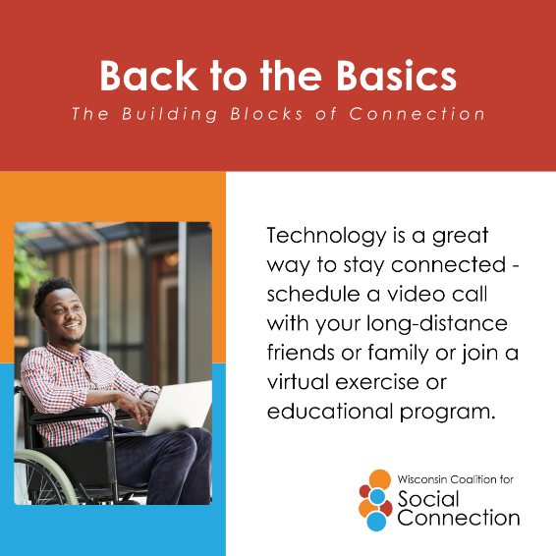 | There are many ways to stay connected at the tip of your fingers.  Learn more and join the movement at ConnectWI.org. #ConnectWI #BacktotheBasics #BuildingBlocksofConnection
11/15 | 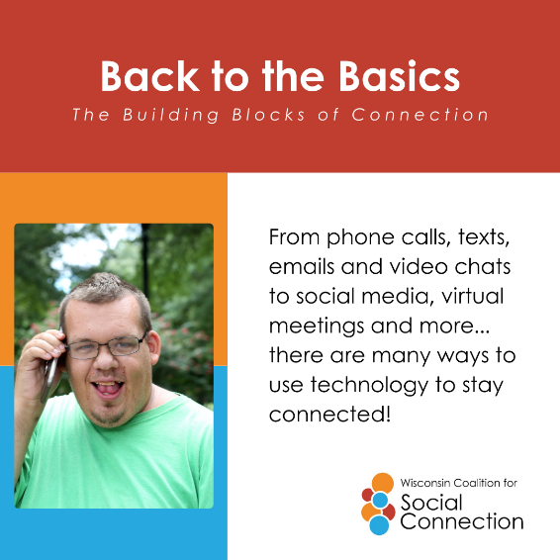 | Reach out! Is there someone in your family or neighborhood who may be lonely and isolated? Not able to connect in person? There are many ways to use technology to stay connected.  Learn more and join the movement at ConnectWI.org. #ConnectWI #BacktotheBasics #BuildingBlocksofConnection
11/16  *Last day of Social Connection Awareness Week | 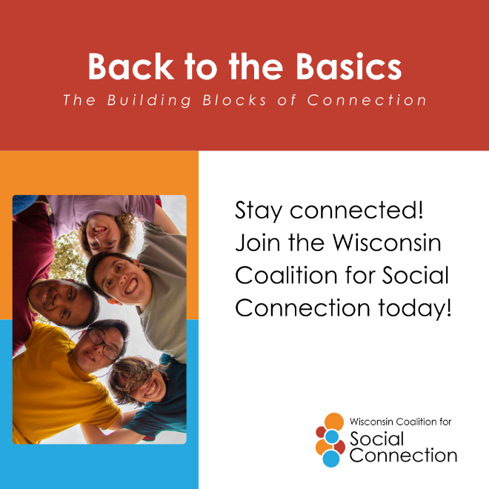 | We may be wrapping up Social Connection Awareness Week but that doesn’t mean the conversation is ending. Learn more and join the movement at ConnectWI.org. #ConnectWI #BacktotheBasics #BuildingBlocksofConnection

