EngAged Calendar of Social Engagement Opportunities
9/7/25  *Grandparents Day | 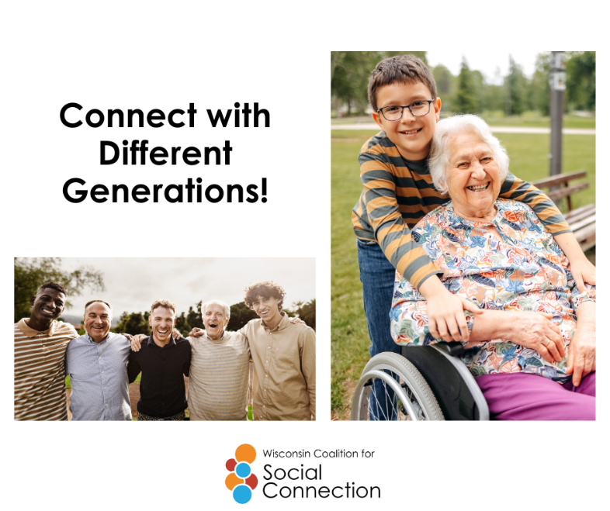 | Some of the best connections happen when we bridge the generation gap.  Share stories, learn new skills, and see the world through someone else’s eyes. Who can you reach out to today?  Looking to build stronger social connections? Visit ConnectWI.org for tools, resources, and ideas. #ConnectWI
9/15/25  *September 15 – October 15 is National Hispanic Heritage Month | 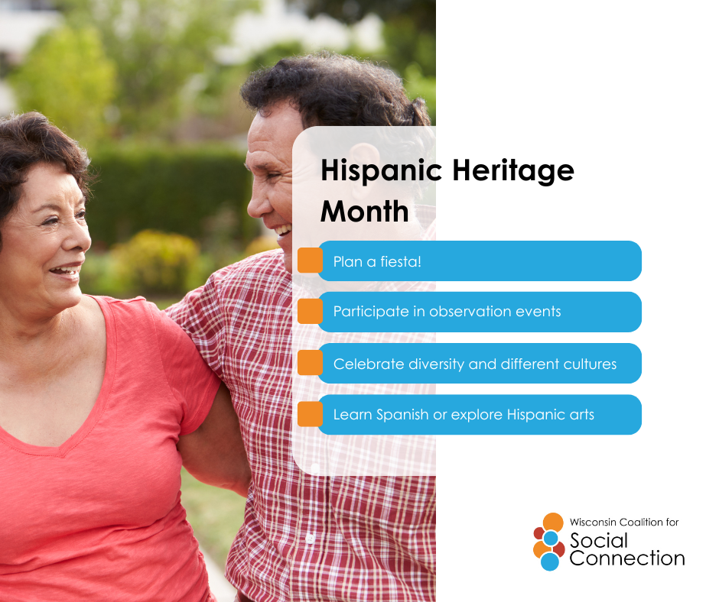 | Hispanic Heritage Month is a celebration of culture, history, and the connections that bring us together.  From family traditions to neighborhood gatherings, social connection strengthens our communities and honors the stories that shape us.  Looking to build stronger social connections? Visit ConnectWI.org for tools, resources, and ideas. #ConnectWI
9/20/25  *National Dance Day | 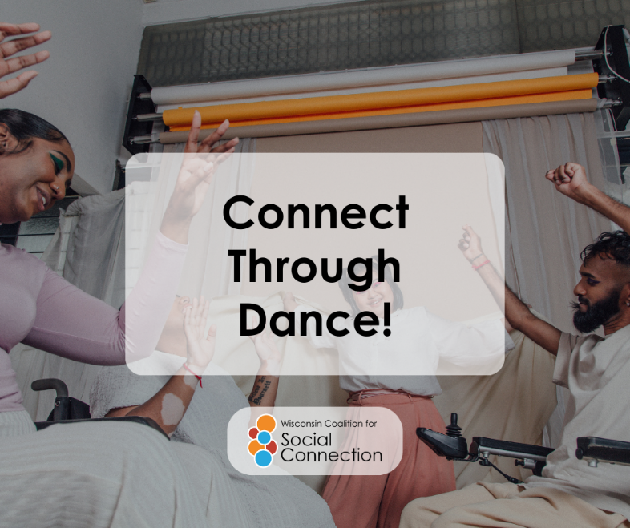 | Dance has a way of bringing people together—no words needed. 💃🕺  Whether it’s a community class, a cultural celebration, or just moving to your favorite song with friends, dance connects us through rhythm, joy, and shared moments.  Stay connected to what matters most. Visit ConnectWI.org for ideas and tools to help stay active and engaged. #ConnectWI
9/21/25  *World Alzheimer’s Day | 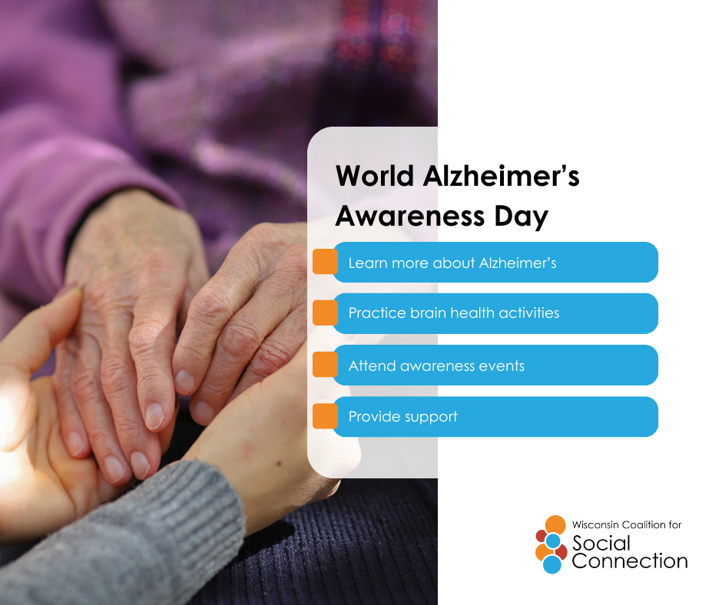 | On World Alzheimer’s Day, we’re reminded that connection is powerful—especially for those living with Alzheimer’s and their loved ones. 💜  Simple moments like sharing a story, looking at old photos, or enjoying music together can spark joy and strengthen bonds.  Looking to build stronger social connections? Visit ConnectWI.org for tools, resources, and ideas. #ConnectWI
9/28/25  *Good Neighbor Day | 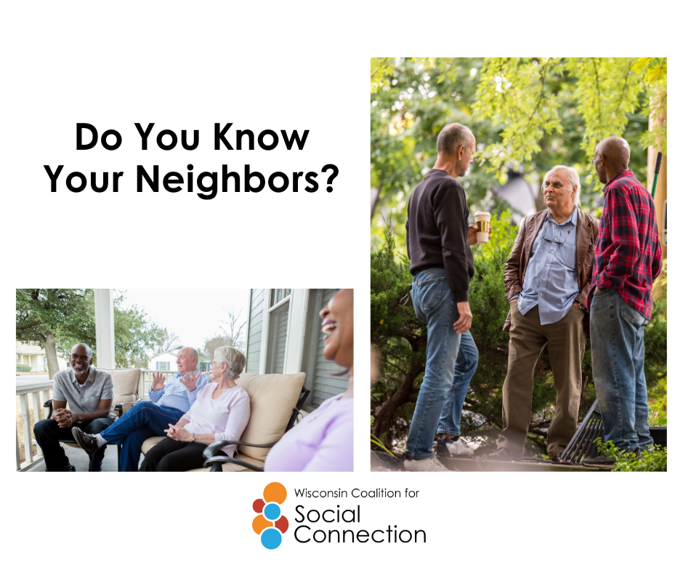 | Strong communities start with simple hellos. 👋  Whether it’s lending a hand, sharing a cup of coffee, or chatting across the fence, connecting with neighbors builds trust, support, and belonging. Take a moment today to reach out—you never know the difference it might make.  Stay connected to what matters most. Visit ConnectWI.org for ideas and tools to help stay active and engaged. #ConnectWI

