EngAged Calendar of Social Engagement Opportunities
10/1  *National Arts & Humanities Month | 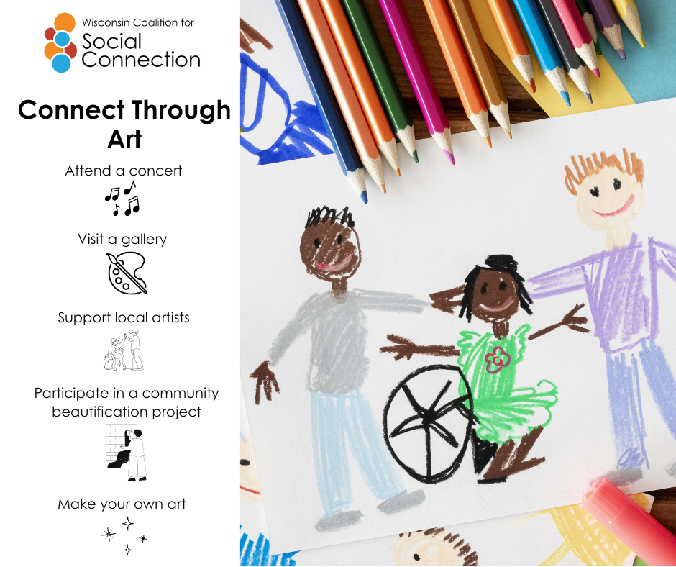 | Art isn’t just about what we create—it’s about the moments we share. This month, try making space for art in your life:  🖌️ Join a local workshop  🖼️ Visit a community art show  💬 Share a piece of art that inspires you with a friend  Because when we create and experience art together, we don’t just make beauty—we make belonging. Visit ConnectWI.org for more ways to stay engaged. #ConnectWI
10/6  *Active Aging Week is 10/6-10/12 | 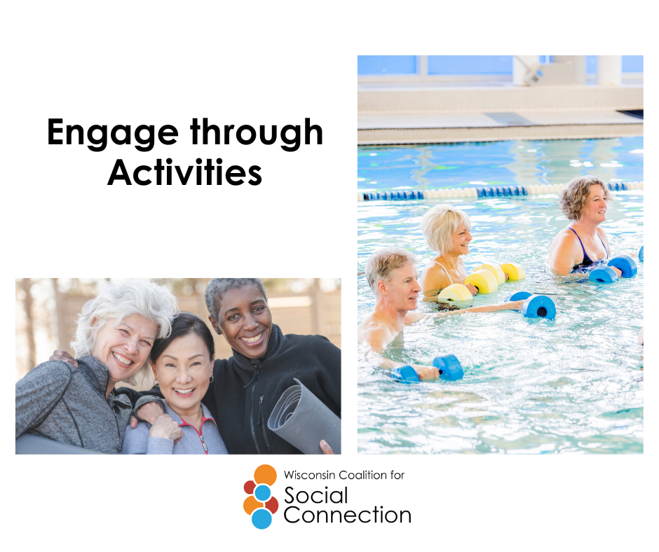 | Active aging isn’t just about staying strong—it’s about staying connected.  Walking with a neighbor, joining a fitness class, or dancing with friends keeps our bodies moving and our social circles thriving.  Being active together builds health, happiness, and community. Let’s keep moving—together. Visit ConnectWI.org for more ways to stay engaged. #ConnectWI
10/13  *National Train Your Brain Day | 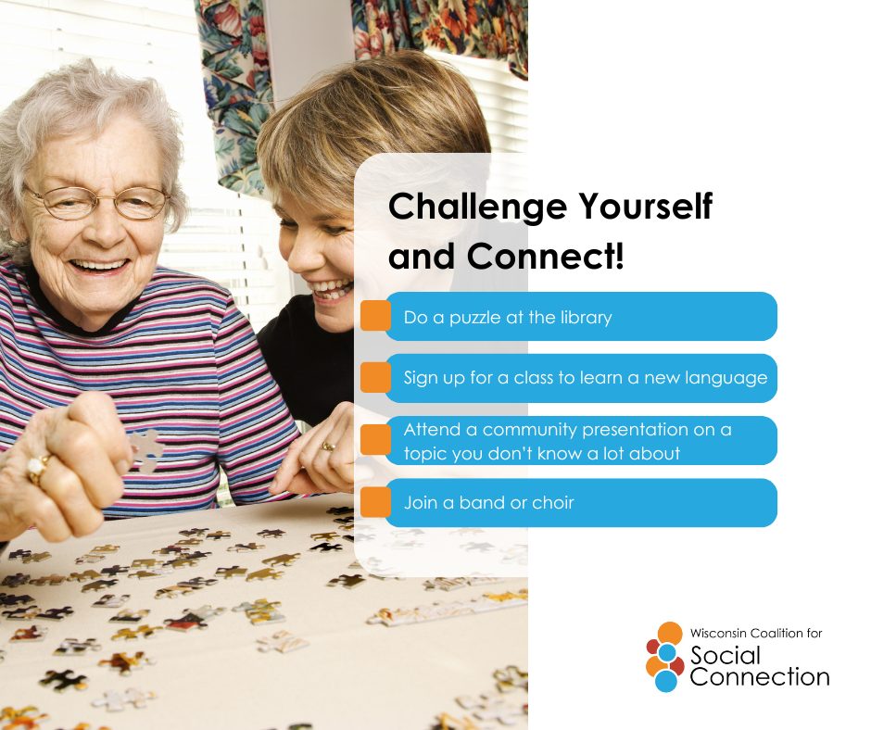 | 🧠 A healthy brain loves company!  Brain-boosting activities aren’t just puzzles and crosswords—they’re also conversations, learning new skills, and connecting with others.  Keeping our minds sharp is easier—and more fun—when we do it with others. Visit ConnectWI.org for more ways to stay engaged. #ConnectWI
10/25  *National Make a Difference Day | 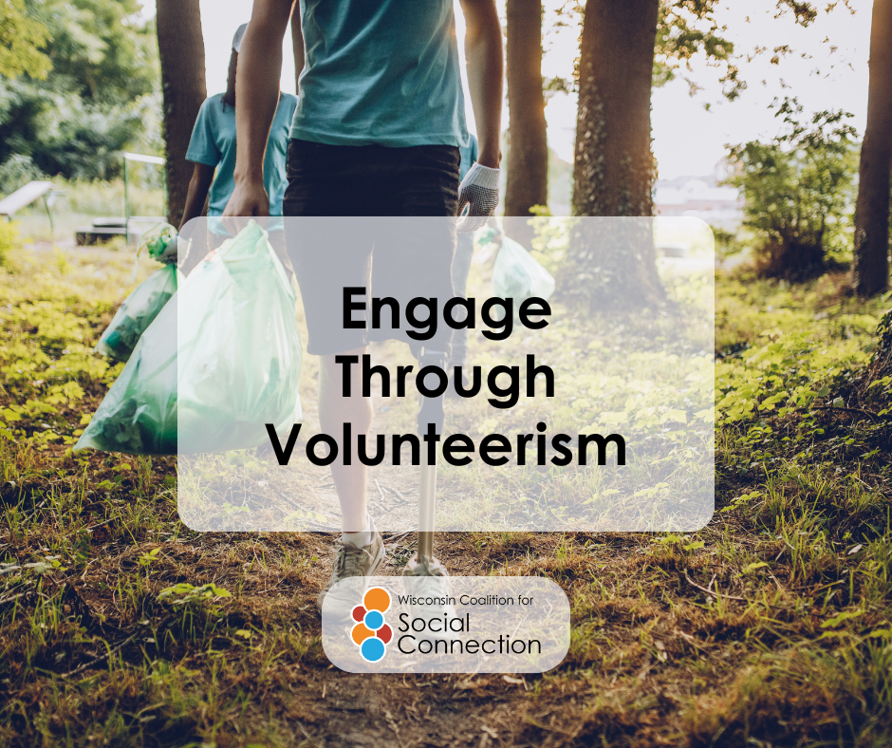 | Connection grows when we give our time.  Volunteering isn’t just about helping others—it’s about building relationships, sharing purpose, and strengthening community.  Whether it’s mentoring, serving meals, or lending a hand at local events, volunteering connects us in powerful ways.  Visit ConnectWI.org for more ways to stay engaged. #ConnectWI

