Date | Asset | Suggested Message for Social Media
11/9  *First day of Social Connection Awareness Week | 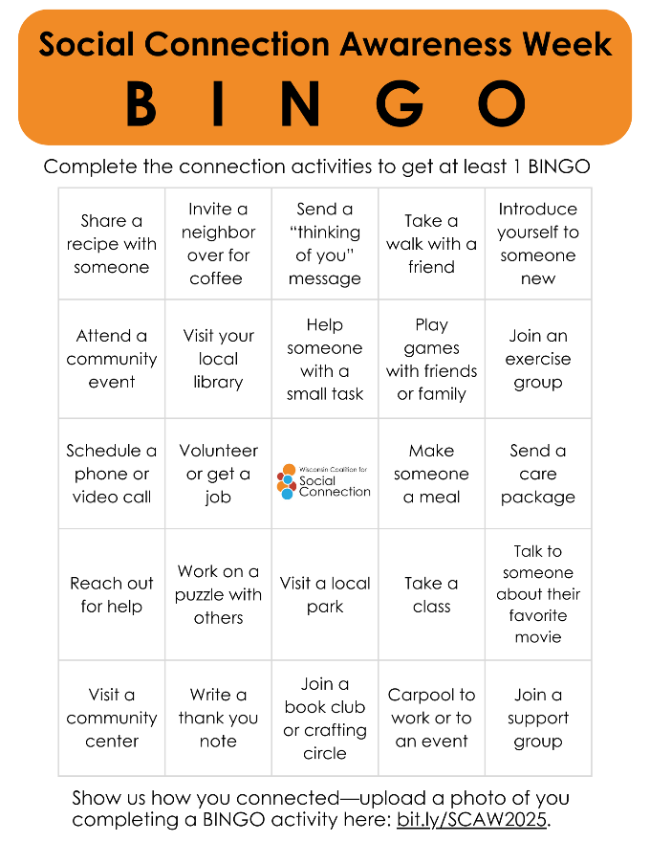 | Social Connection Awareness Week is here!  This year’s theme is From Neighbors to Networks – Connection Happens Here, and we’re celebrating with a fun way to get involved: our Social Connection BINGO card! On each square, you’ll find a simple way to reach out, build relationships, and strengthen community—like calling a friend, checking in on a neighbor, or joining a local activity.  ✅ Complete at least 1 “BINGO” (or the whole card!) and see how small steps create big connections. Show us how you connected by taking a photo of you completing a BINGO activity and uploading it here: bit.ly/SCAW2025  Let’s celebrate connection throughout Wisconsin this week!  Learn more at ConnectWI.org. #ConnectWI #FromNeighborsToNetworks  #ConnectionHappensHere
11/10 | 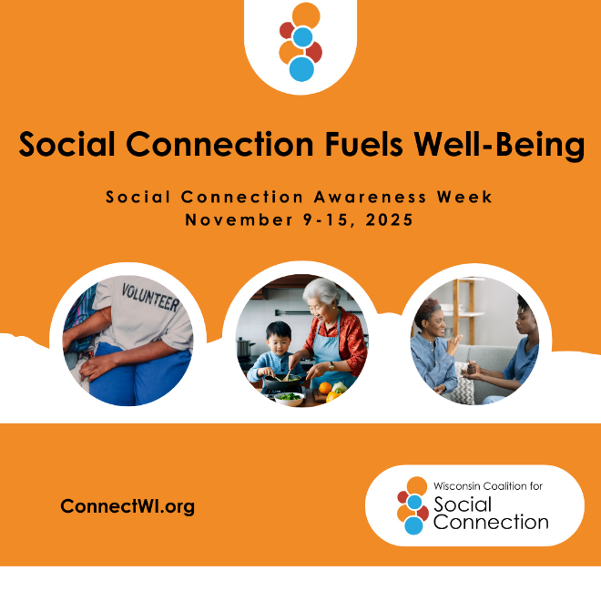 | Did you know social connection—just like physical activity and a balanced diet— is important for your health?  Being socially connected:  ❤️ Lowers the risk of heart disease and stroke  🧠 Protects against dementia  😊 Reduces depression and anxiety  🌙 Improves sleep and reduces stress  Connection isn’t just good for the soul—it’s good for the body too. Reach out, stay connected, and invest in your health through community.  #ConnectWI #FromNeighborsToNetworks  #ConnectionHappensHere
11/11 | 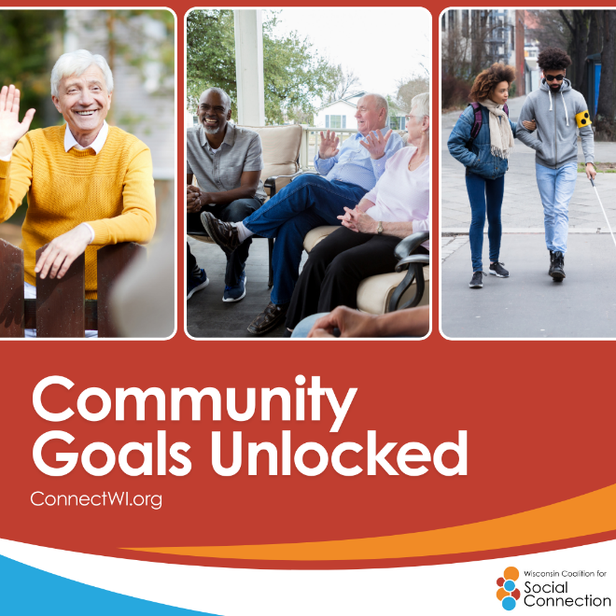 | Strong neighborhoods are built on connection.  A simple wave to a neighbor, a quick chat on the sidewalk, or checking in on someone down the street can spark a sense of belonging that makes communities healthier and safer.  When we connect where we live, we create neighborhoods that care, trust, and thrive—together.  #ConnectWI #FromNeighborsToNetworks  #ConnectionHappensHere
11/12 | 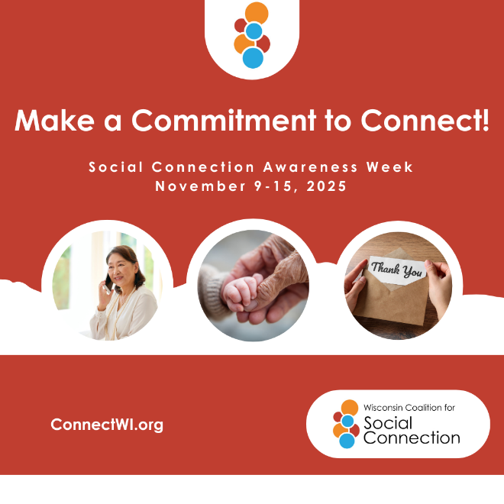 | Strong connections start with simple commitments. This Social Connection Awareness Week, make a commitment to connect:  - Call a friend or family member and check-in  - Spend time with people from different generations  - Write a “thank you” card or share your appreciation for others  - Volunteer or join a local group  - Say “hi” to someone new  Small steps lead to stronger bonds, healthier lives, and more connected communities. Let’s commit to connection—together. #ConnectWI #FromNeighborsToNetworks  #ConnectionHappensHere
11/13 | 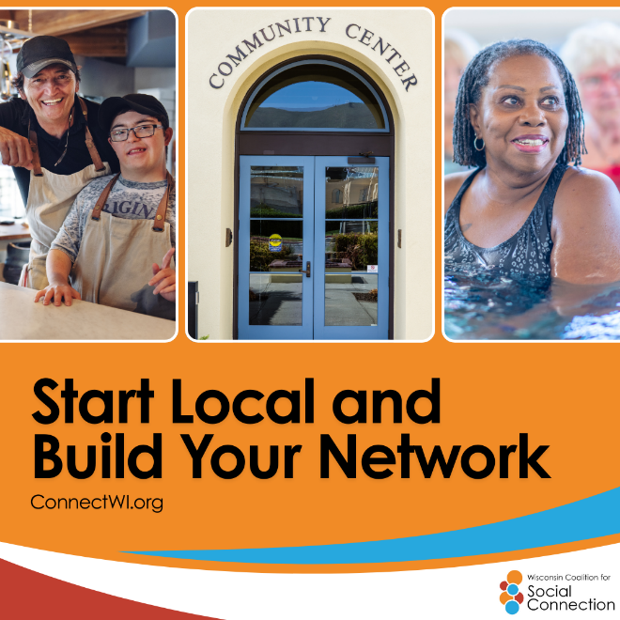 | Big networks start with small steps. Every smile to a neighbor, every shared story or experience, every helping hand builds a web of connection.  Local bonds don’t just stay local—they ripple outward, creating networks of care, trust, and belonging. When we connect close to home, we strengthen the fabric of our entire community. #ConnectWI #FromNeighborsToNetworks  #ConnectionHappensHere
11/14 | 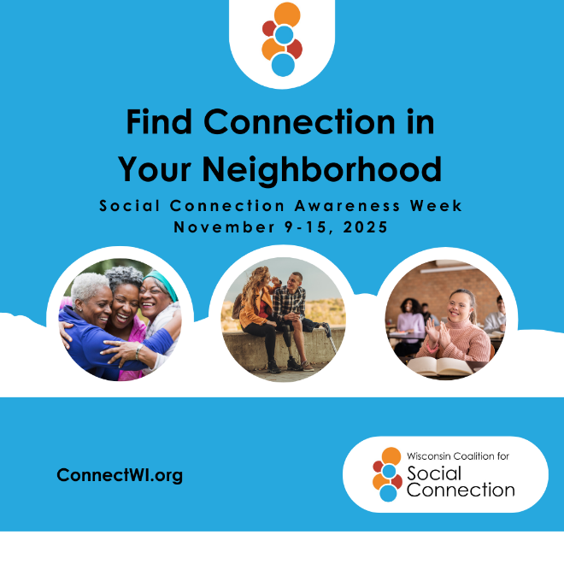 | Connection starts with small steps! Looking to feel more connected in your community? Try:  🤝 Volunteering with a local group  ☕ Sharing coffee with a neighbor  🚶 Joining a walking club or fitness class  📚 Visiting your library or community center  🎶 Attending a local concert, market, or festival  Every “hello” builds a stronger community and helps you—and your neighbors—be more socially connected. #ConnectWI #FromNeighborsToNetworks  #ConnectionHappensHere
11/14 |  | Don’t forget to play Social Connection Awareness Week BINGO and show us how you’re connecting this week!  Upload a photo (or 2!) of you completing a BINGO activity here: bit.ly/SCAW2025.  We can’t wait to see all the amazing connections happening throughout Wisconsin this week and beyond! #ConnectWI #FromNeighborsToNetworks  #ConnectionHappensHere
11/15 | 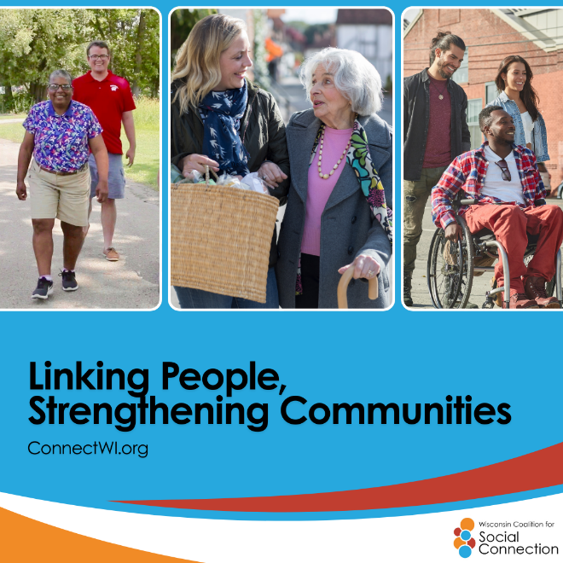 | As we close out Social Connection Awareness Week, let’s remember—connection isn’t just nice to have—it’s vital for our health and well-being.  Strong relationships can lower the risk of heart disease, stroke, dementia, depression, and anxiety. Just as important, they bring joy, belonging, and purpose to our daily lives.  The week may be ending, but the commitment to connect continues. Reach out, stay engaged, and keep building the networks that help us all thrive. #ConnectWI #FromNeighborsToNetworks  #ConnectionHappensHere

