EngAged Calendar of Social Engagement Opportunities
11/1  *November is National Family Caregivers Month | 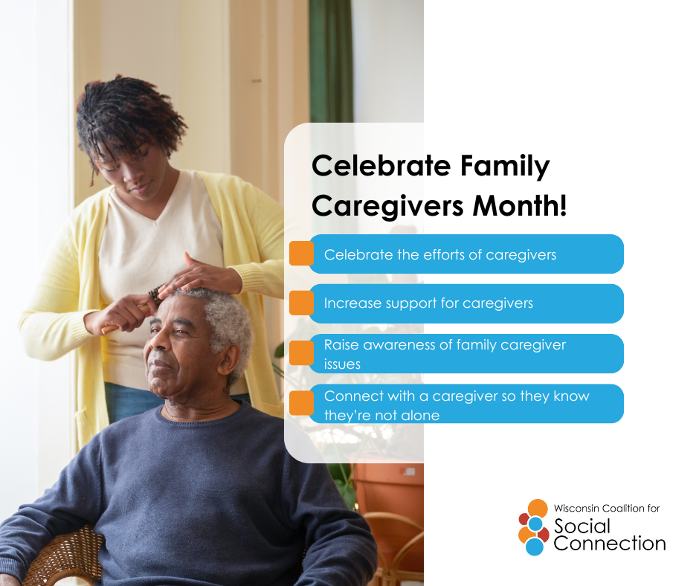 | Caring for a loved one can be deeply meaningful — but it can also feel isolating at times. That’s why staying socially connected is just as important for caregivers as it is for those they care for.  Reaching out to friends, joining a support group, or simply taking time to connect with others can boost mental health, reduce stress, and help caregivers feel less alone.  This week, take a moment to check in with a caregiver you know — a call, a visit, or even a quick message can make all the difference.  Want to strengthen your connections? Visit ConnectWI.org for inspiration. #ConnectWI
11/11  *November is National Veterans and Military Families Month | 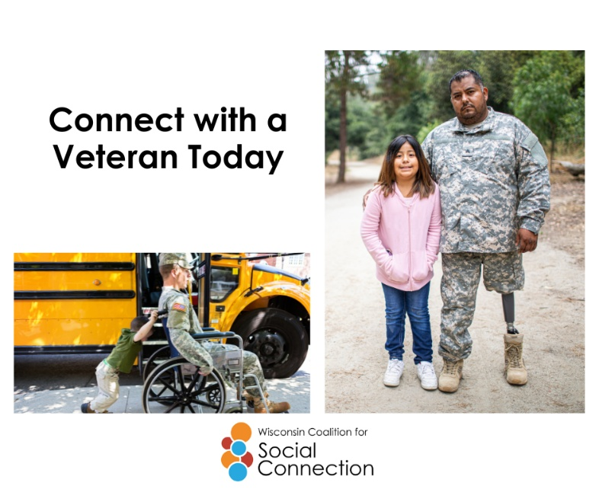 | November is National Veterans and Military Families Month — a time to honor the strength, sacrifice, and resilience of those who serve and those who support them.  Military life often means change, challenge, and separation — but it’s also built on connection, camaraderie, and community. Reaching out, sharing experiences, and staying connected helps protect well-being and strengthens the bonds that keep us all grounded.  This month, take a moment to connect with a veteran or military family — a simple “thank you” or conversation can mean more than you know.  Discover more ways to build connection — head to ConnectWI.org. #ConnectWI
11/20  *National Rural Health Day | 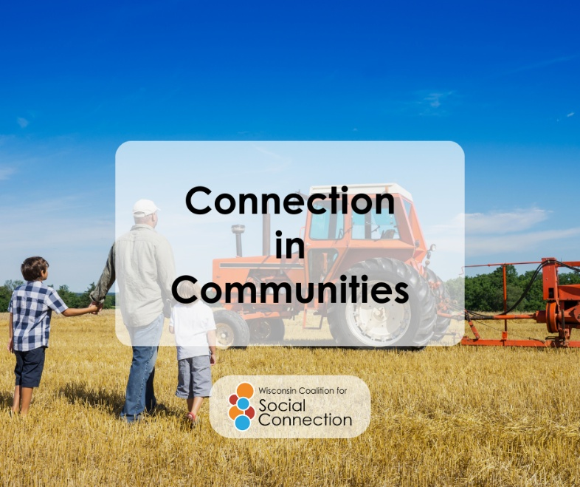 | Today we celebrate the #PowerOfRural — the heart of communities where neighbors become family and connection runs deep.  Rural America thrives on the spirit of togetherness — where people look out for one another, pursue their dreams, and build local businesses that keep communities strong and contribute to our nation’s well-being.  Here’s to the connections that make rural communities truly remarkable.  Visit ConnectWI.org to stay engaged in your community. #ConnectWI
11/26  *November is Native American Heritage Month | 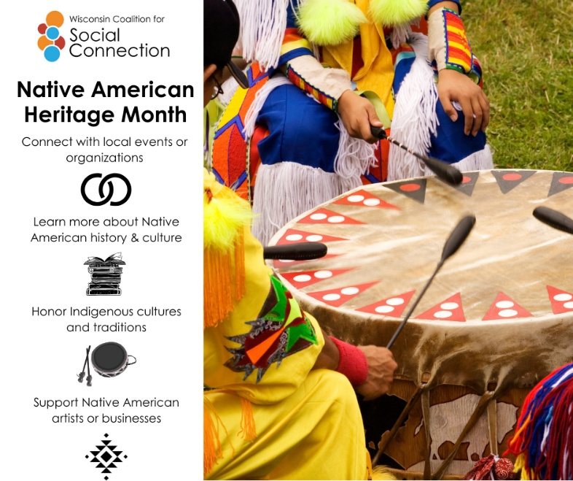 | As Native American Heritage Month comes to a close, we celebrate the deep traditions of community, storytelling, and connection that have always been at the heart of Indigenous cultures.  These connections — to family, community, and the land — remind us that well-being grows strongest when we care for one another.  Let’s carry that spirit forward all year long by building relationships, sharing stories, and honoring the wisdom of those who came before us.  Keep the conversation going! Learn more at ConnectWI.org. #ConnectWI

