EngAged Calendar of Social Engagement Opportunities
12/6  *Write to a Friend Month |  | Texting is easy, but letters are special. 💌 Write a note to a friend or family member — especially someone you haven’t heard from in a bit. It’s a meaningful way to reconnect and show you care.  Discover more ways to build connection — head to ConnectWI.org. #ConnectWI #SocialConnection
12/18 | 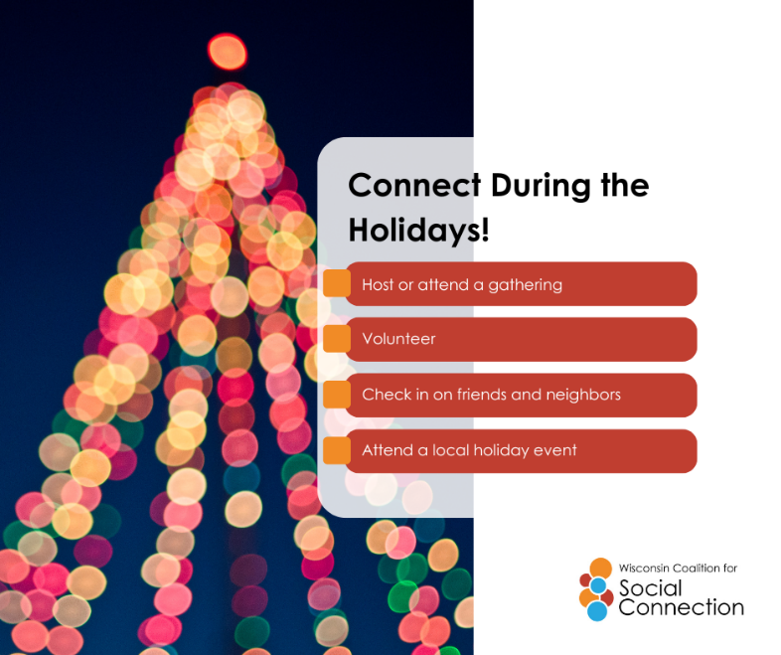 | The holidays are the perfect time to connect! Reach out to family and friends to celebrate the season — whether it’s over coffee, a video call, or a cozy gathering. And don’t forget to check with your local Aging & Disability Resource Center (ADRC) or senior center for fun virtual or in-person holiday events happening near you! 🎁  Discover more ways to build connection — head to ConnectWI.org. #ConnectWI #SocialConnection
12/21  *Crossword Puzzle Day | 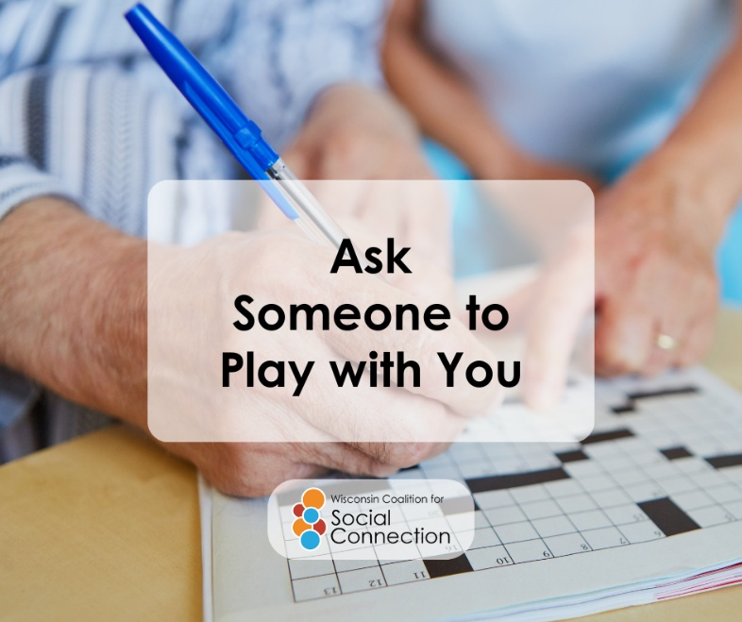 | Before phones and social media, we used to knock and ask, “Wanna play?” 👋 Maybe it’s time we bring that back! Invite someone out for coffee, a walk, or a game — connection doesn’t have to be complicated.  Want to strengthen your connections? Visit ConnectWI.org for inspiration. #ConnectWI #SocialConnection

