EngAged Calendar of Social Engagement Opportunities
1/4  *National Hobby Month | 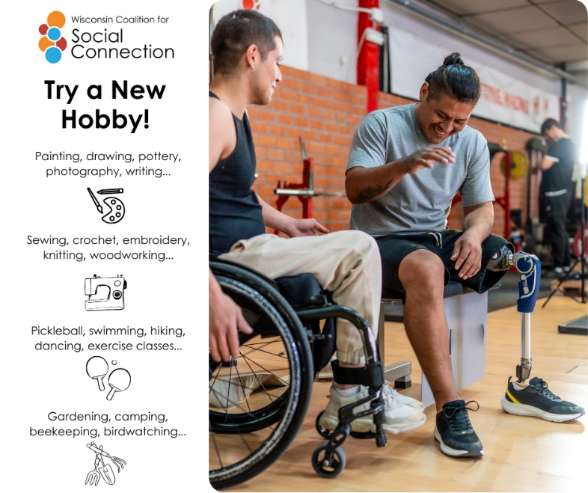 | Trying something new can open the door to new friendships, too! 🎨🎶🌱  Starting a new hobby—whether it’s art, music, gardening, cooking, or a fitness class—creates natural opportunities to meet people who share your interests and passions.  Learning together, laughing through mistakes, and celebrating progress all help build meaningful connections. You don’t have to be an expert—just be curious and open. A new hobby might become your new favorite way to stay socially connected and engaged.  Discover more ways to build connection — head to ConnectWI.org. #ConnectWI #SocialConnection
1/11  *Universal Letter Writing Week | 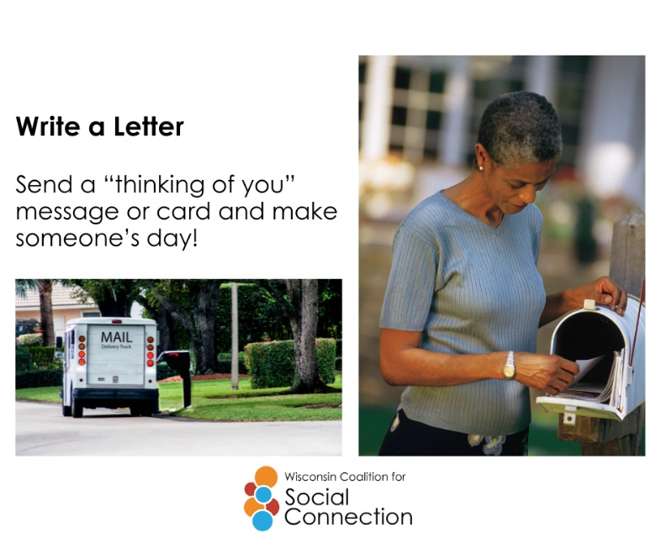 | In a world of quick texts and emails, a handwritten letter can mean so much more. ✉️  Taking the time to write a note to a friend or loved one shows care, thoughtfulness, and connection — and it often creates a lasting memory.  Writing letters can strengthen relationships, reconnect you with someone you haven’t spoken to in a while, and brighten someone’s day in a meaningful way. Grab a pen, share a story, say thank you, or simply say hello. Small gestures like these can make a big difference in staying connected.  Discover more ways to build connection — head to ConnectWI.org. #ConnectWI #SocialConnection
1/19  *Martin Luther King Jr. Day/National Day of Service | 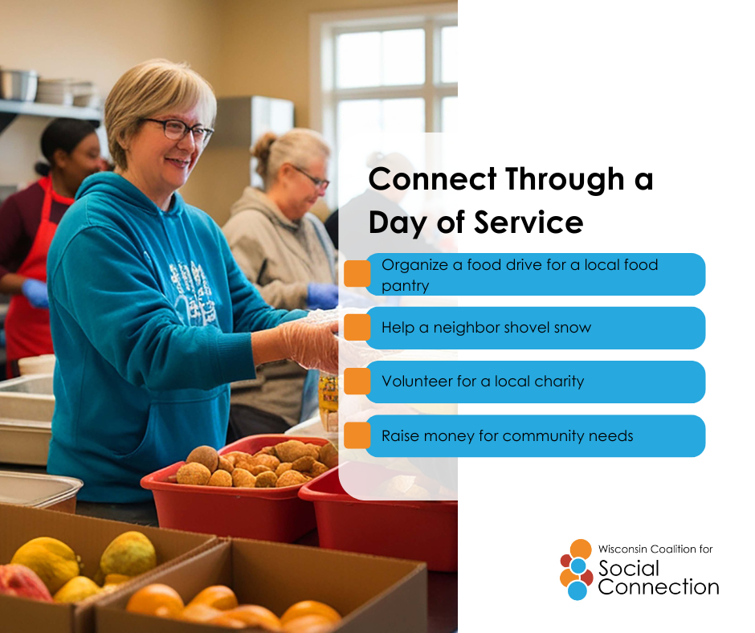 | Serving others is more than giving your time — it’s a powerful way to connect. 🤝  When you volunteer, you meet people who share your values, build friendships, and feel a stronger sense of belonging in your community.  Whether it’s helping at a local event, mentoring, delivering meals, or supporting a cause you care about, volunteering creates meaningful connections while making a difference. Giving back doesn’t just strengthen communities — it strengthens our social connections too.  Discover more ways to build connection — head to ConnectWI.org. #ConnectWI #SocialConnection
1/29  *National Puzzle Day | 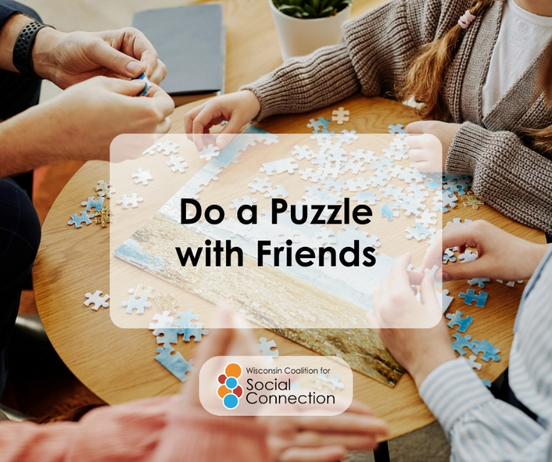 | Connecting with others doesn’t always have to be complicated — sometimes it’s as simple as sitting down to solve a puzzle together. 🧩  Working on puzzles with friends or family (or even strangers at the library!) encourages conversation, laughter, teamwork, problem-solving, and connection.  Whether it’s a jigsaw, crossword, or word game, shared activities like puzzles help strengthen social bonds and support cognitive health at any age. Invite a friend over, start a puzzle night, or join a local puzzle group — connection happens one piece at a time!  Discover more ways to build connection — head to ConnectWI.org. #ConnectWI #SocialConnection

