EngAged Calendar of Social Engagement Opportunities
2/2  *Black History Month | 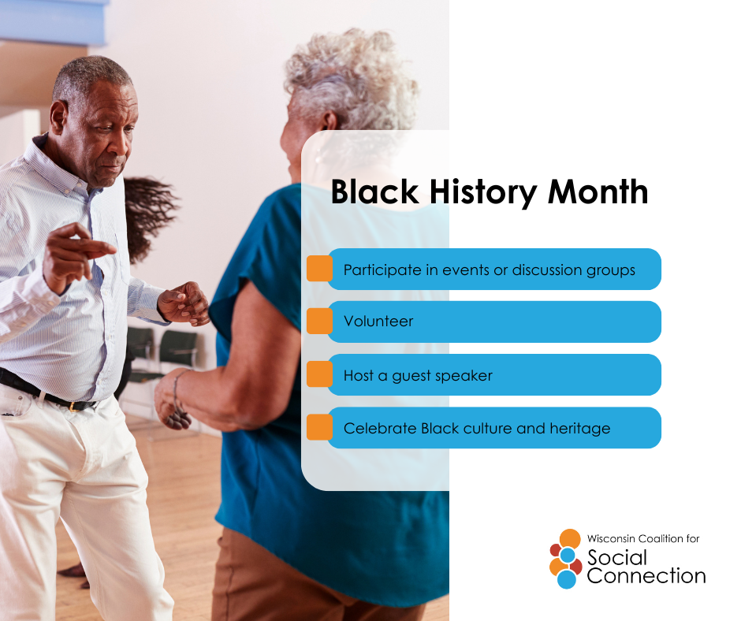 | February is #BlackHistoryMonth—a time to honor the achievements, resilience, and contributions of Black leaders, innovators, and communities, past and present.  It’s also an opportunity to build meaningful connections: by listening to lived experiences, learning from Black voices, supporting Black-owned businesses and organizations, and creating spaces where everyone feels seen and valued.  Discover more ways to build connection — head to ConnectWI.org. #ConnectWI #SocialConnection
2/11  *National Make a Friend Day | 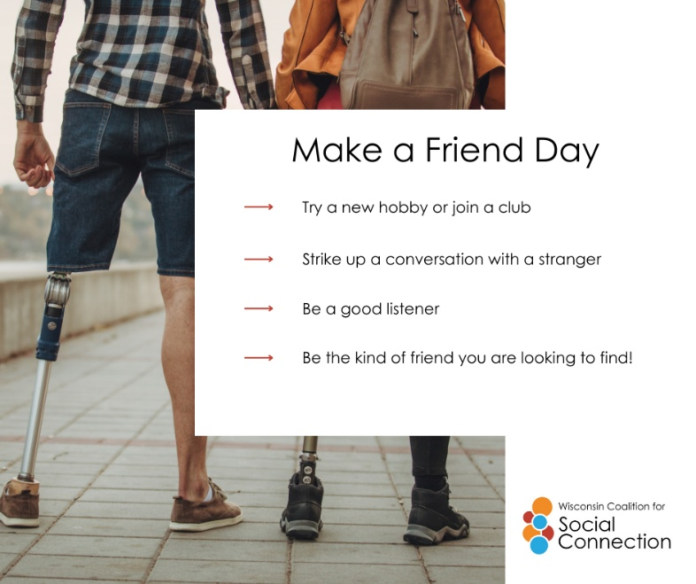 | Friendship and social connection matter at every stage of life. Staying connected helps reduce loneliness, supports mental and emotional well-being, and strengthens independence.  Building connections can start small: a phone call, a shared meal, a class, or a community group. Accessible programs, peer support, and inclusive spaces make it possible for everyone to belong and build meaningful relationships.  Discover more ways to build connection — head to ConnectWI.org. #ConnectWI #SocialConnection
2/20  *National Caregivers Day | 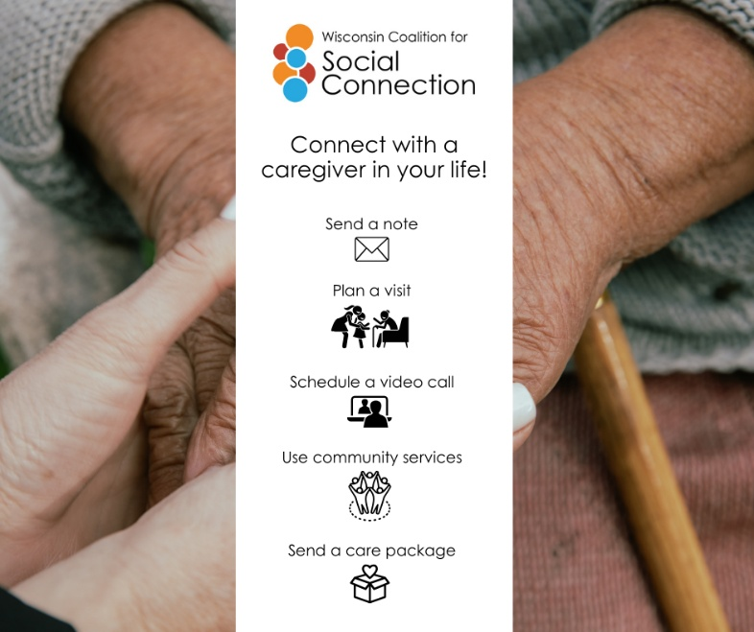 | While caregivers devote so much of themselves to others, their need for connection and support deserves attention as well. Meaningful connections can reduce stress, prevent burnout, and remind caregivers they’re not alone.  Whether it’s a support group, a quick check-in with a friend, or time spent with others who understand the caregiving journey, social connection helps caregivers recharge and stay resilient.  Caring for others starts with caring for yourself—and connection is a powerful form of support.  Discover more ways to build connection — head to ConnectWI.org. #ConnectWI #SocialConnection

