EngAged Calendar of Social Engagement Opportunities
March  Women’s History Month | 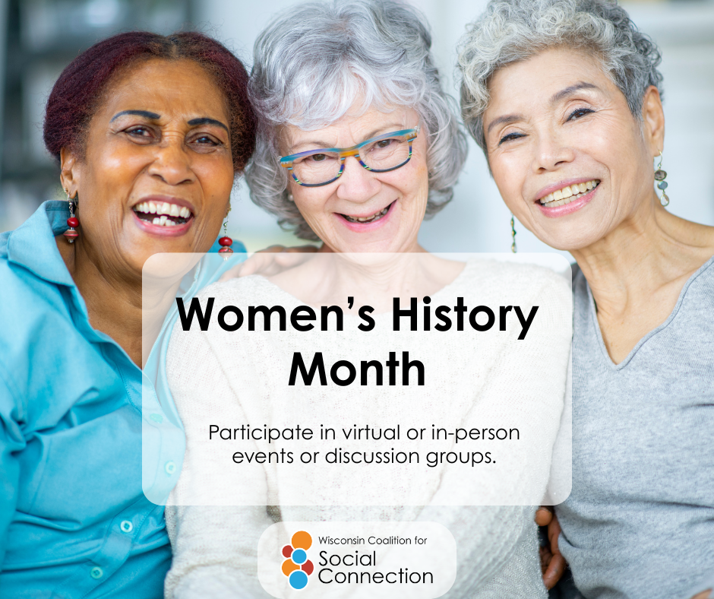 | The month of March is Women’s History Month!  Learn and celebrate the contributions of women to events in history by participating in virtual or in-person events and discussion groups.  Celebrate the women in your life!  Give your mom, sister, wife, girlfriend, friends, or yourself a handwritten card, flowers, chocolate, and/or a hug!  Let them feel your appreciation!  Discover more ways to build connection — head to ConnectWI.org. #ConnectWI #SocialConnection
National Nutrition Month |  | Discover the power of nutrition, it’s National Nutrition Month!  Invite friends and family over for dinner or potluck! Food is a great way to create community and connections :~)  Discover more ways to build connection — head to ConnectWI.org. #ConnectWI #SocialConnection
3/12  National Plant a Flower Day |  | March 12 is National Plant a Flower Day!  It smells like springtime! Celebrate the start of a new season by planting a flower with a friend or join a community garden.  This day highlights the importance of flowers in supporting pollinators and reducing stress. It is ideal for starting seeds indoors or planting frost-tolerant varieties like pansies. Once the flower grows, it can make a great gift for a loved one too!  Discover more ways to build connection — head to ConnectWI.org. #ConnectWI #SocialConnection
3/19  National Let’s Laugh Day |  | Knock, knock,  Who’s there?  It’s National Let’s Laugh Day!  It’s National Let’s Laugh Day Who?  Share a joke with a friend or go to a Comedy club! Afterall, laughter is the best medicine.  Discover more ways to build connection — head to ConnectWI.org. #ConnectWI #SocialConnection
National Craft Month | 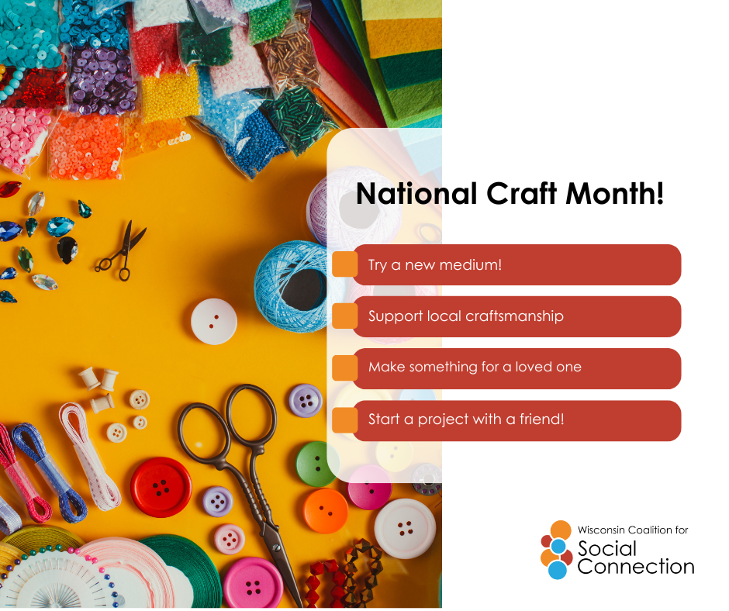 | National Craft Month, celebrated every March, is a month-long initiative established in 1994 to encourage creativity, promote crafting skills, and foster the appreciation of handmade items. It serves as a time for individuals to start new projects, learn new skills, and support the crafting community.  Studies show crafting increases dopamine, reduces stress, and improves mental well-being.  Discover more ways to build connection — head to ConnectWI.org. #ConnectWI #SocialConnection

