EngAged Calendar of Social Engagement Opportunities
April  National Volunteer Month | 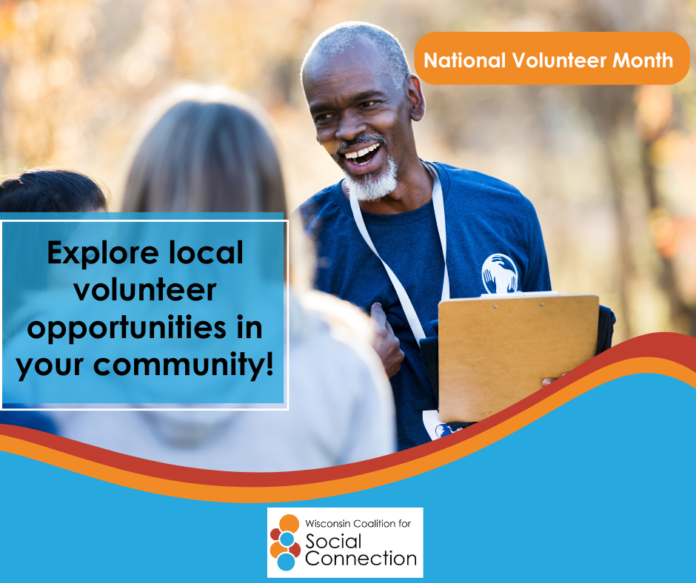 | April is the National Month of Volunteering!  Volunteer at your local food pantry, community center, library, humane society, school, or somewhere else in your community. It’s a great way to connect, give back, and enjoy an enormous sense of wellbeing!  If you’re interested in volunteer opportunities in Wisconsin, go here: https://www.servewisconsin.wi.gov/volunteer-opportunities.  Discover more ways to build connection — head to ConnectWI.org. #ConnectWI #SocialConnection
April 1st  National Walking Day | 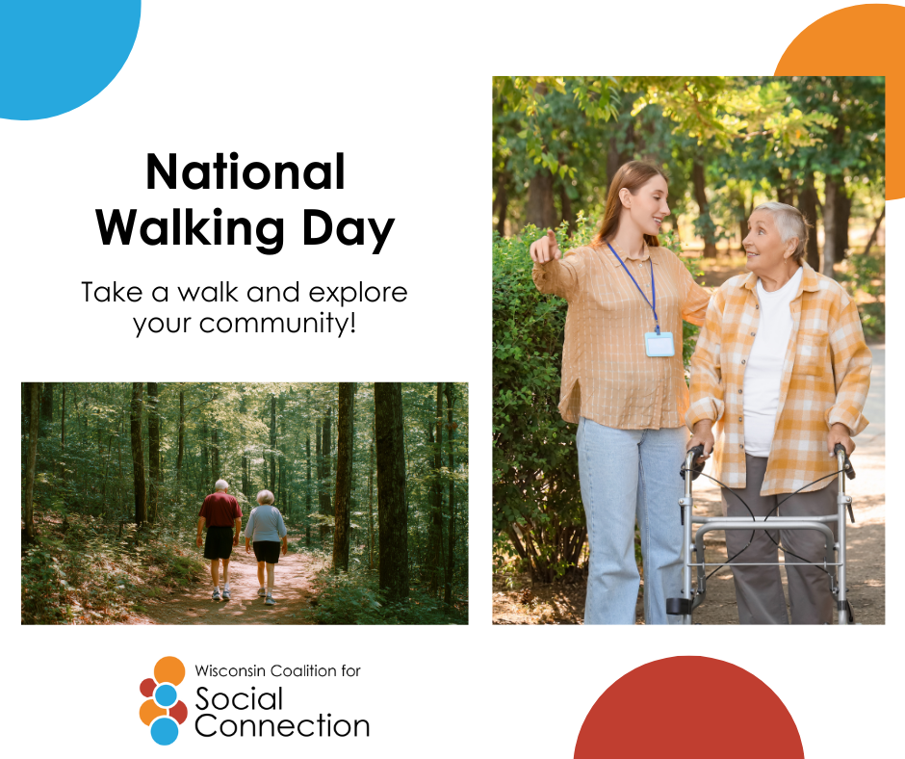 | April 1st is National Walking Day!  Sponsored by the American Heart Association, this initiative encourages taking at least 30 minutes to walk per day, aiming to reduce sedentary lifestyles and promote heart health and physical activity.  Take a walk around your neighborhood or explore a new area! Walking is a great way to get exercise and meet new people.  Discover more ways to build connection — head to ConnectWI.org. #ConnectWI #SocialConnection
April 6–12  National Library Week  April 6–12 |  | National Library week is April 6–12!  Celebrate how libraries transform our lives and strengthen our communities. Check out your local libraries and explore all they have to offer – from programs and events, support groups, book delivery, and more, libraries are a great way to get together with others and connect with your community.  Discover more ways to build connection — head to ConnectWI.org. #ConnectWI #SocialConnection
April 22  Earth Day | 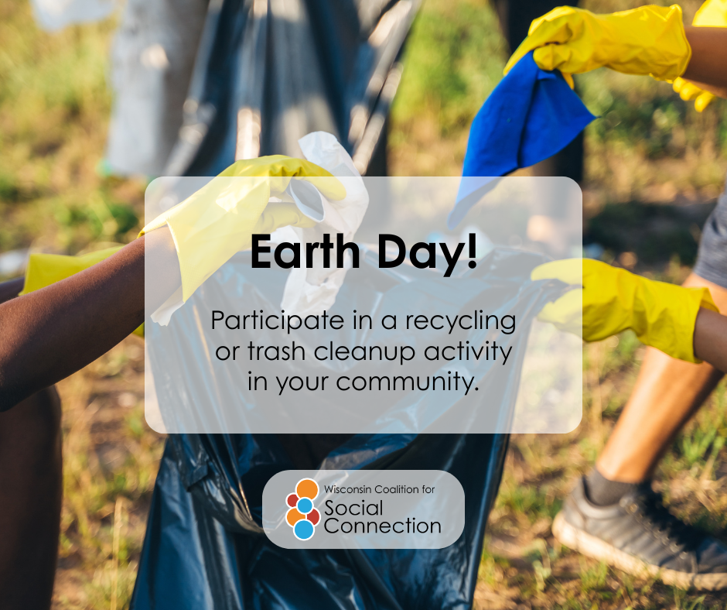 | It’s Earth Day! How will you celebrate? Let us know in the comments.  This is a great day to serve and connect with your community and other like-minded people! Enjoy a cleaner and more connected environment.  Discover more ways to build connection — head to ConnectWI.org. #ConnectWI #SocialConnection

