Loneliness Awareness Week
June 15 | 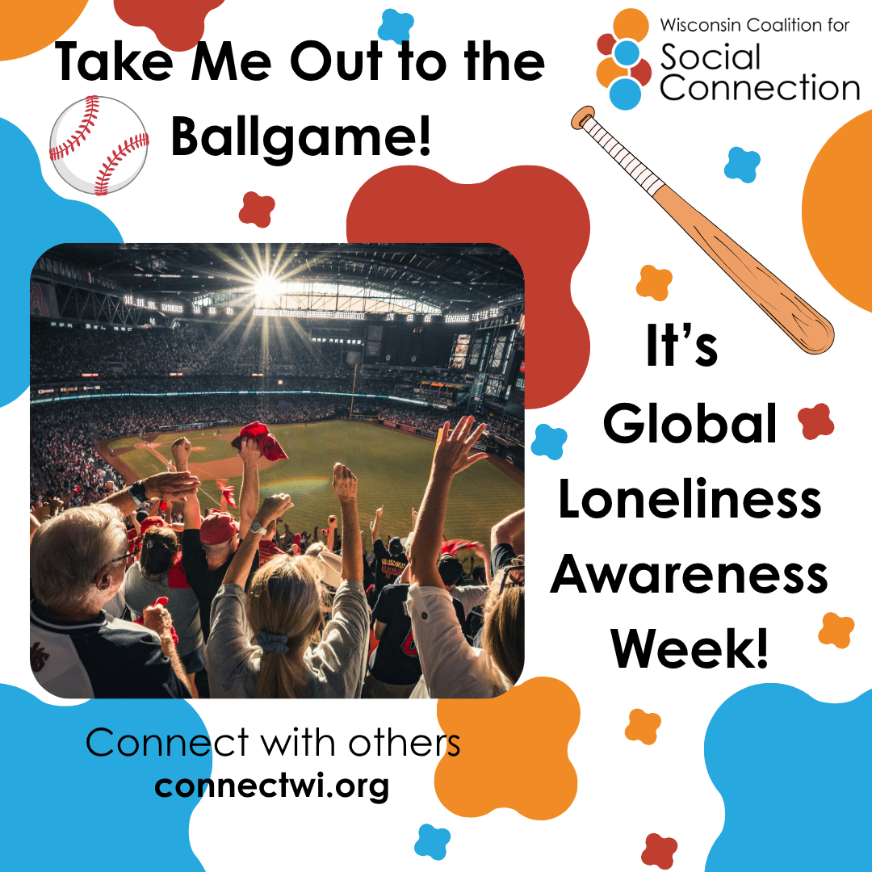 | ⚾🎶 Take Me Out to the Ballgame…🎶  There’s something special about a day at the ballpark—the cheers, the laughter, the shared moments that turn into lasting memories. But it’s not just about the game, it’s about the people you experience it with.  This season, make it more than just a game. Invite a friend, call a family member, or reach out to someone new and bring them along. Whether you're in the stands, at home watching together, or simply sharing a conversation, those moments of connection matter.  Discover more ways to build connection — head to ConnectWI.org. #TakeMeOuttotheBallgame #GivingLonelinessAVoice #GlobalLonelinessAwarenessWeek #ConnectWI
June 16 | 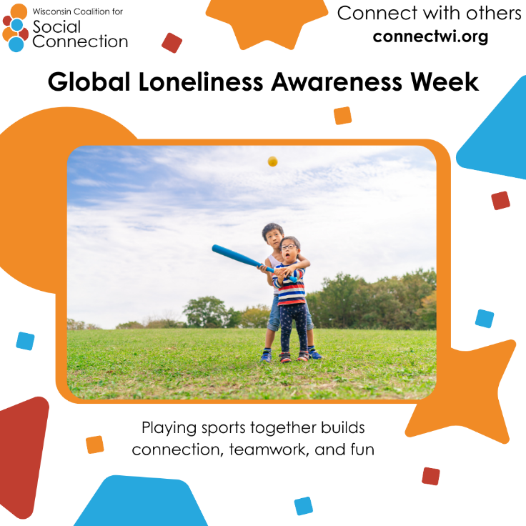 | It’s day 2 of Global Loneliness Awareness Week!  Sports have been a pillar of community building since the beginning of human civilization. Whether it’s playing together or watching a game, we can build connection and belonging through sports!  Invite someone in your life to watch or play a game with you this week.  Discover more ways to build connection — head to ConnectWI.org. #TakeMeOuttotheBallgame #GivingLonelinessAVoice #GlobalLonelinessAwarenessWeek #ConnectWI
June 17 | 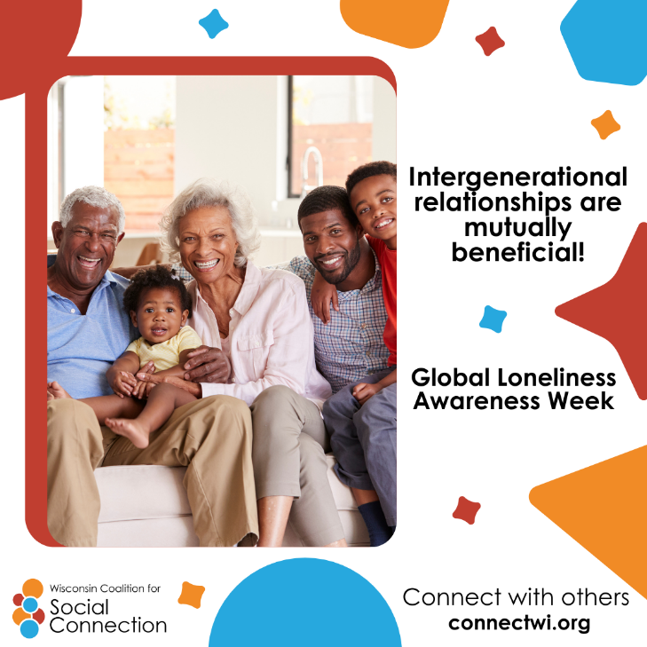 | It’s day 3 of Global Loneliness Awareness Week!  Celebrate by inviting your grandma, grandpa, grandchild, or parents to watch a game together!  Intergenerational bonding has shown to improve physical and mental health for older adults and increase empathy and patience in children!  Discover more ways to build connection — head to ConnectWI.org. #TakeMeOuttotheBallgame #GivingLonelinessAVoice #GlobalLonelinessAwarenessWeek #ConnectWI
June 18 | 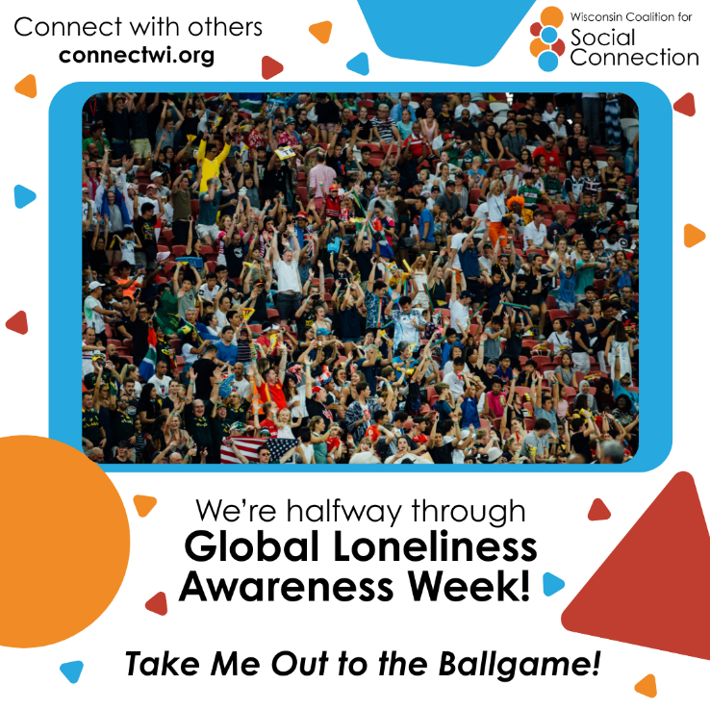 | We’re about halfway through Global Loneliness Awareness Week! ⚾  Many people are feeling disconnected from their communities and the world around them, now more than ever. Today is the perfect time to step up to the plate and reach out to that person you’ve been meaning to connect with.  Give them a call, send a message, or better yet—invite them out and say, “Take me out to the ballgame!” ⚾  Discover more ways to build connection — head to ConnectWI.org. #TakeMeOuttotheBallgame #GivingLonelinessAVoice #GlobalLonelinessAwarenessWeek #ConnectWI
June 19 | 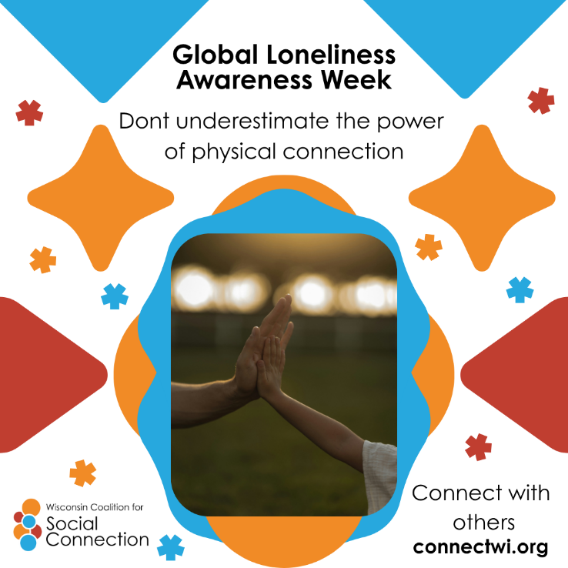 | It’s day 5 of Global Loneliness Awareness Week!  In a world where we’re more digitally connected than ever, in-person connections are priceless.  In-person interaction builds stronger, trusting relationships through nonverbal cues like body language, tone, and eye contact that digital tools may miss.  The next time you want to watch your favorite team, do it in a place where you can high five the person next to you!  Discover more ways to build connection — head to ConnectWI.org. #TakeMeOuttotheBallgame #GivingLonelinessAVoice #GlobalLonelinessAwarenessWeek #ConnectWI
June 20 | 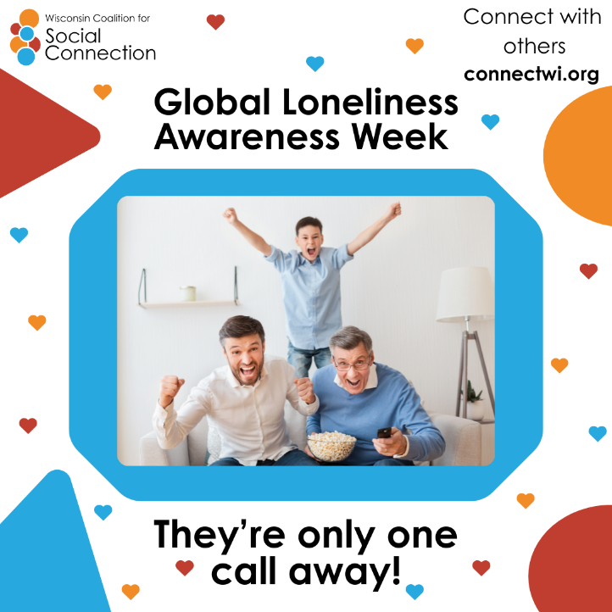 | It’s day 6 of Global Loneliness Awareness Week!  We often underestimate the power of a simple phone call—like a quick pitch that keeps the game of connection going strong. ⚾  Even when life gets busy, a short “hello” can go a long way in keeping your team strong. Call your grandma, mom, dad, sister, or a friend–then round up your crew and watch the game together! ⚾  Discover more ways to build connection — head to ConnectWI.org. #TakeMeOuttotheBallgame #GivingLonelinessAVoice #GlobalLonelinessAwarenessWeek #ConnectWI
June 21 | 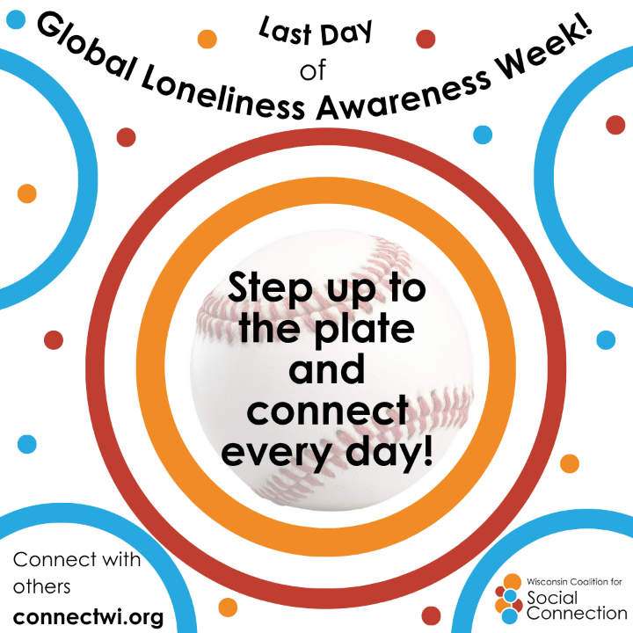 | ⚾ It may be the final inning of Global Loneliness Awareness Week, but social connection isn’t a one-game season—it’s something you can keep playing, building, and enjoying all year long!  If you haven’t made your move yet, it’s never too late to step up to the plate—reach out to a friend, family member, or someone new and make a connection!  Discover more ways to build connection — head to ConnectWI.org. #TakeMeOuttotheBallgame #GivingLonelinessAVoice #GlobalLonelinessAwarenessWeek #ConnectWI

