EngAged Calendar of Social Engagement Opportunities
May  Older Americans Month | 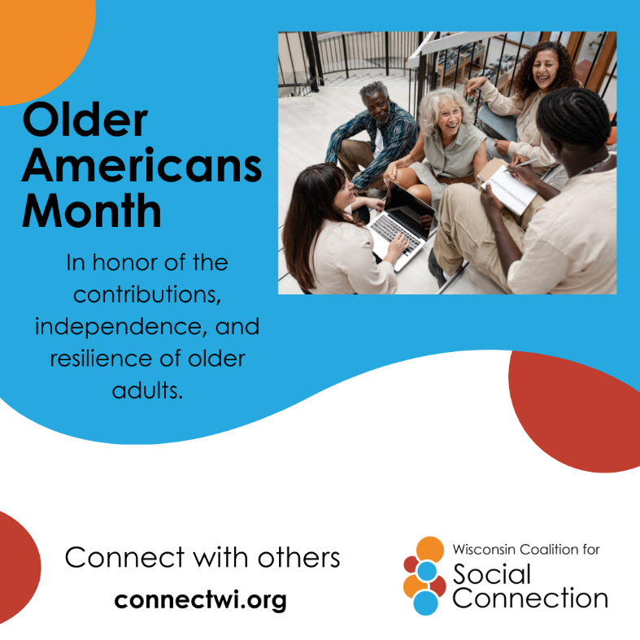 | Older Americans Month honors the contributions, independence, and resilience of older adults. Established in 1963, the annual observance focuses on strengthening community support, highlighting aging trends, and promoting active, engaged lifestyles.  Discover ways to build connection as we age — head to ConnectWI.org. #ConnectWI #SocialConnection
May  Asian Pacific Islander American Heritage Month | 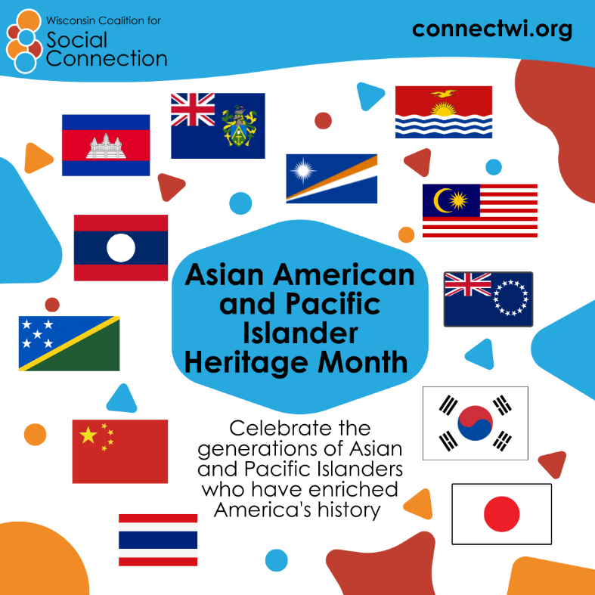 | Asian American and Pacific Islander Heritage Month is about paying tribute to the generations of Asian and Pacific Islanders who have enriched America's history and are instrumental in its future success.  Participate in virtual or in-person recognition events or discussion groups.  Discover more ways to build connection — head to ConnectWI.org. #ConnectWI #SocialConnection
May  National Pet Month | 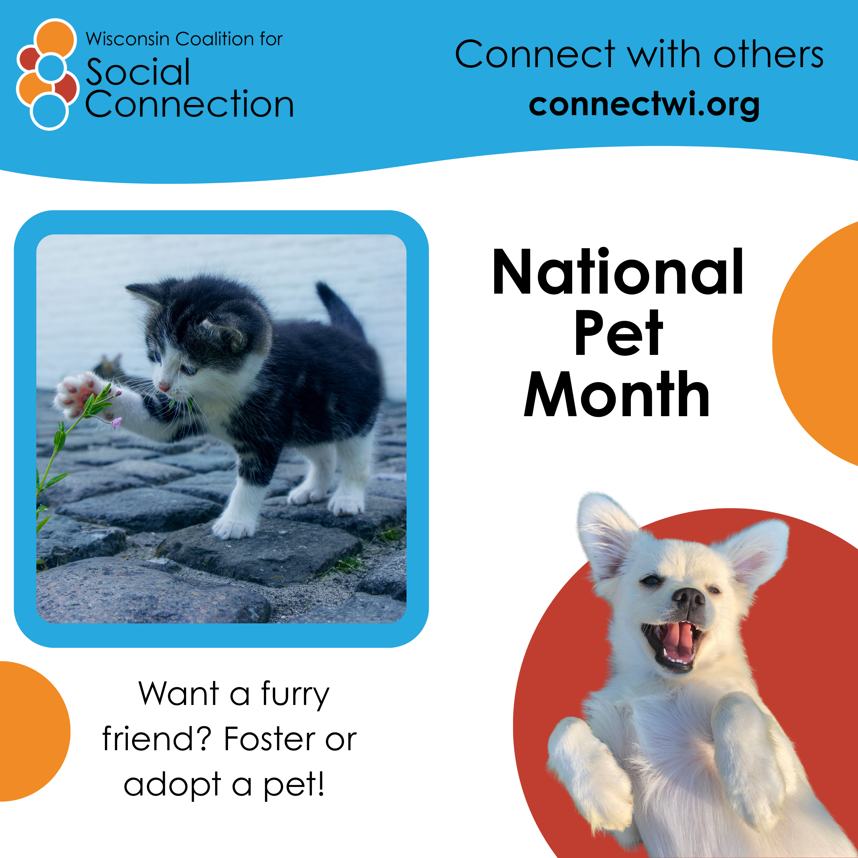 | Want a furry friend? Foster or adopt a pet!  National Pet Month is celebrated annually in the United States throughout May to honor the companionship of pets, promote responsible ownership, and encourage pet adoption.  Did you know? Pets are beneficial for our physical and emotional health! Consider volunteering, visiting your local dog park, and spoiling the pets in your life.  Discover more ways to build connection — head to ConnectWI.org. #ConnectWI #SocialConnection
May 1st  Older Adult Mental Health Awareness Day | 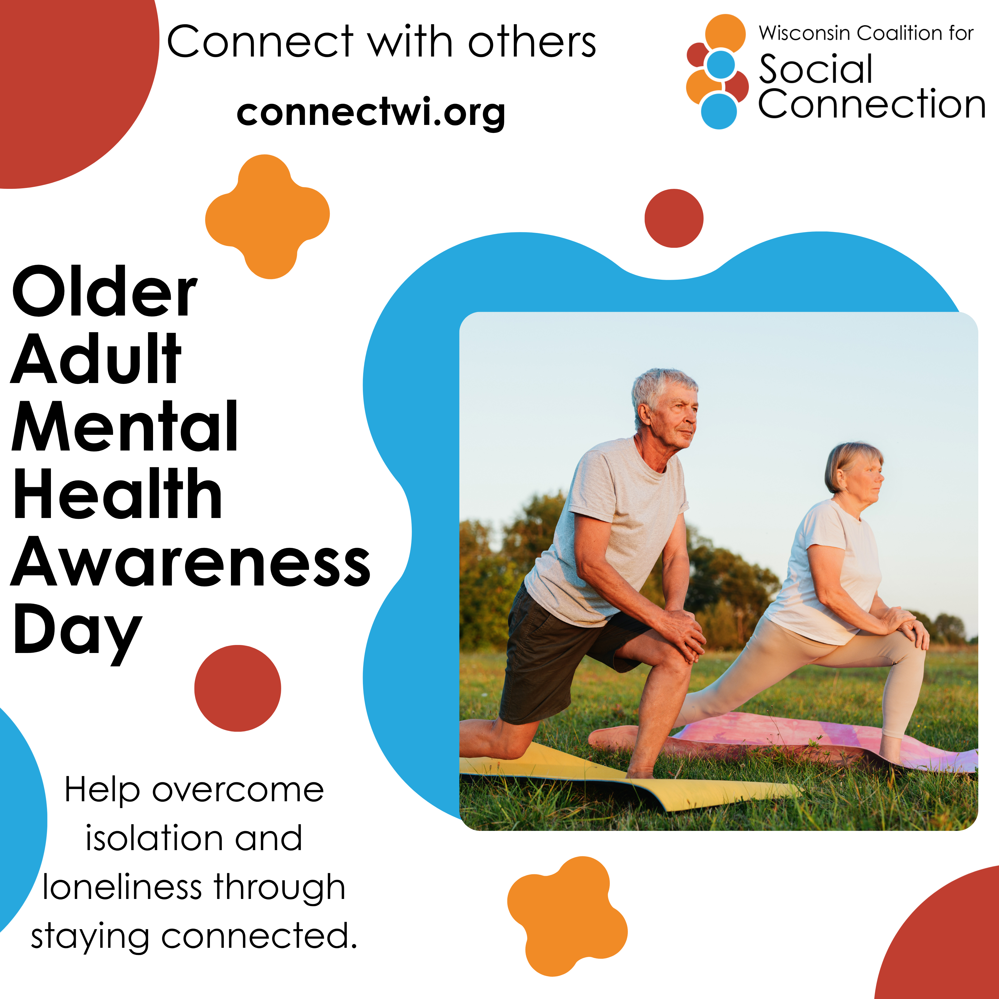 | As we age, caring for our mental health is just as important as caring for our physical health. Staying connected with others, keeping our mind active, and taking time for things we enjoy can boost our mood and reduce stress and loneliness.  Simple things—like a phone call with a friend, a walk outside, or trying something new—can make a big difference. We deserve to feel supported, connected, and well every day.  Discover ways to build connection — head to ConnectWI.org. #ConnectWI #SocialConnection
May 2nd  National Fitness Day | 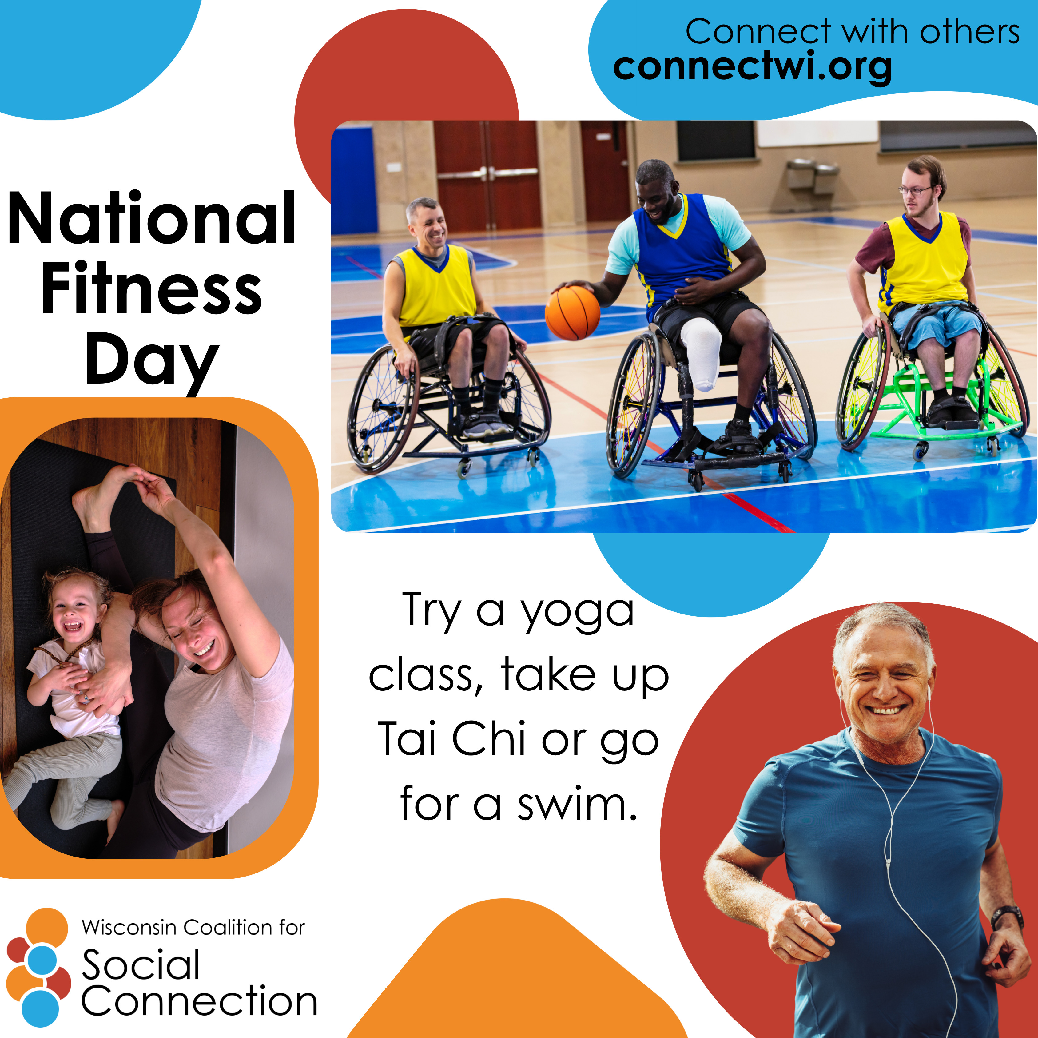 | It’s National Fitness Day! Today is the day that we celebrate and promote physical activity, healthy lifestyles, and making fitness inclusive for everyone!  Invite a friend to play ball, say hello to your neighbors while out for a walk, or get active with someone from a different generation!  Discover more ways to build connection — head to ConnectWI.org. #ConnectWI #SocialConnection
May 16th  National Do Something Good for Your Neighbor Day | 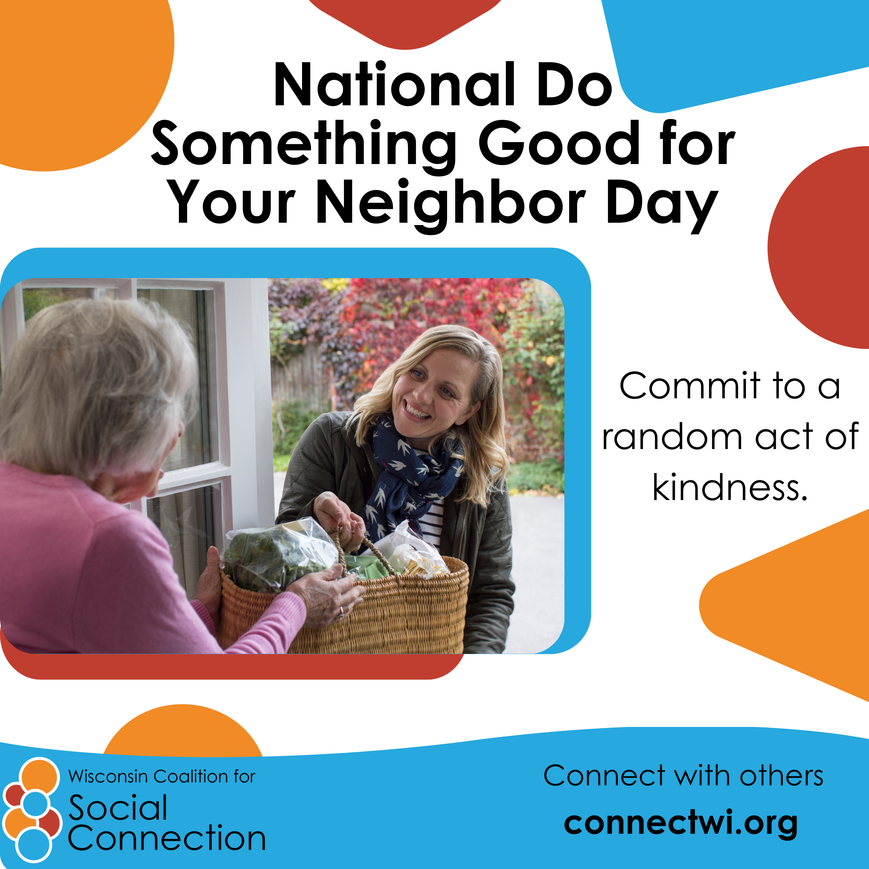 | Do something good for your neighbor day!  Today is all about promoting kindness, community, and stronger neighborhood bonds through small, actionable gestures.  What random act of kindness will you share today? Let us know in the comments!  Discover more ways to build connection — head to ConnectWI.org. #ConnectWI #SocialConnection
May 18th  National Visit Your Relatives Day | 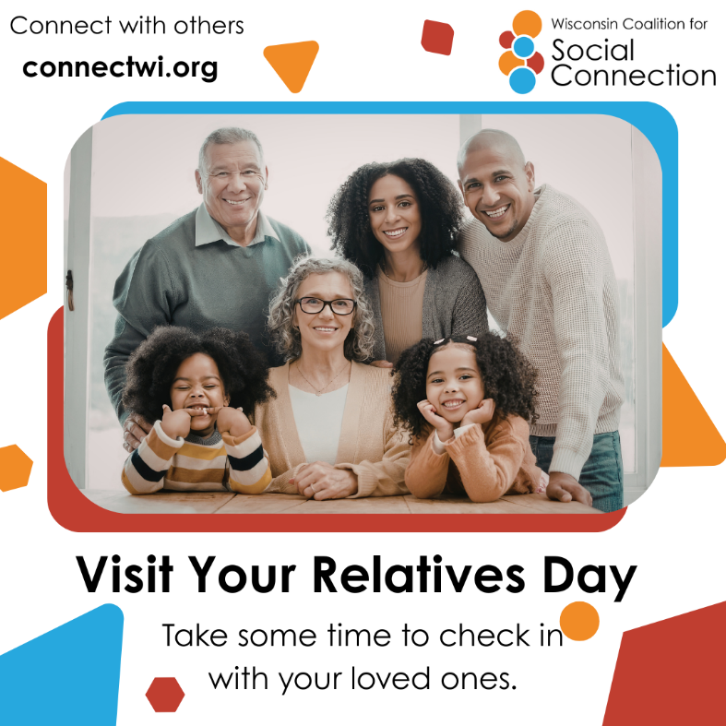 | Visit your relatives or give them a call!  We can combat loneliness by fostering connections with extended or chosen family, and creating lasting memories through in-person visits, phone calls, or video chats.  Discover more ways to build connection — head to ConnectWI.org. #ConnectWI #SocialConnection

