EngAged Calendar of Social Engagement Opportunities
June 1  Social Wellness Month | 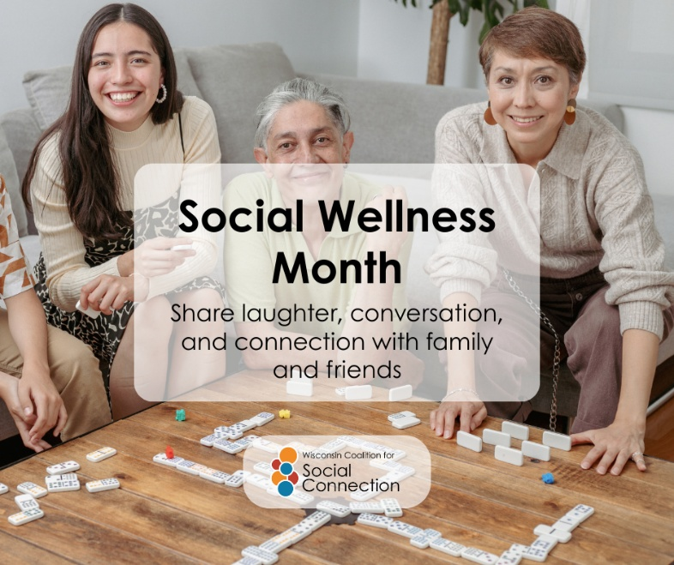 | July is Social Wellness Month!  Social wellness is all about building and maintaining meaningful relationships that help us feel connected, supported, and valued. Whether it's sharing a meal with friends, calling a loved one, joining a community group, or simply checking in on a neighbor, every connection matters.  Strong social connections can improve our physical and mental health, reduce feelings of loneliness, and help us live healthier, happier lives.  This month, make time to connect. Reach out to someone, strengthen an existing relationship, or create a new one. Small moments of connection can have a lasting impact.  Discover more ways to build connection — head to ConnectWI.org. #ConnectWI #SocialConnection
July 11  National Cheer Up the Lonely Day | 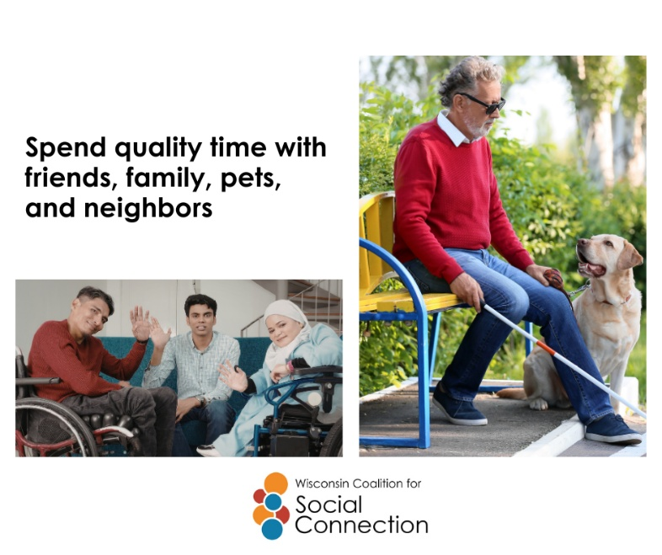 | Spend quality time with a friend. Share a meal with family. Take a walk with a neighbor. Curl up with a beloved pet. These everyday moments of connection can bring joy, comfort, and a sense of belonging.  Strong relationships help us feel supported, strengthen our well-being, and remind us that we're not alone. Whether it's a quick visit, a phone call, or time spent together, small acts of connection can make a big difference.  Today, make time for the people—and pets—who bring happiness to your life. You might brighten their day, too.  Discover more ways to build connection — head to ConnectWI.org. #ConnectWI #SocialConnection
July 15  National Give Something Away Day | 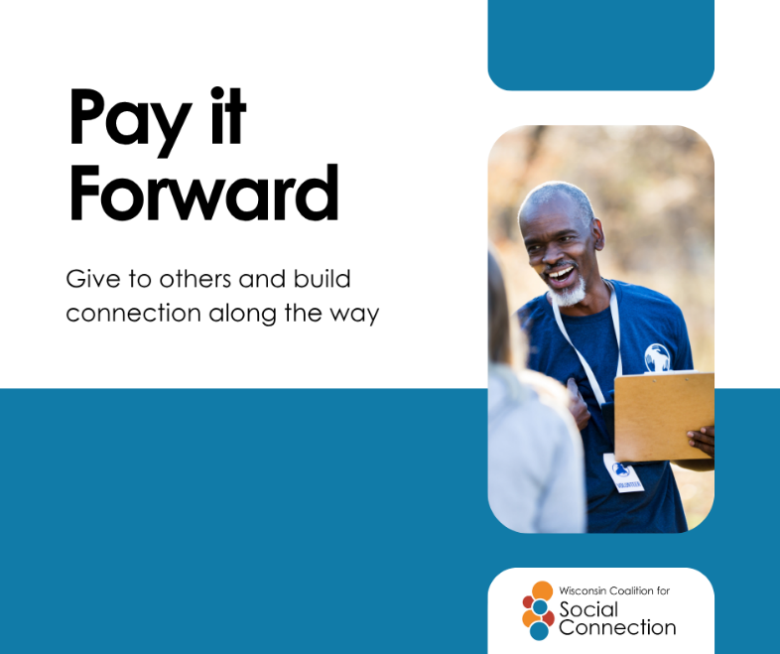 | Giving doesn't always have to mean spending money. A kind word, a helping hand, a ride to an appointment, sharing your time, or passing along something you no longer need can make a meaningful difference in someone's day.  Acts of generosity help strengthen connections, build community, and remind us that we all have something valuable to share.  Today, consider giving away something that could brighten someone else's day—a book, a meal, a smile, your time, or simply a moment of support.  Discover ways to build connection — head to ConnectWI.org. #ConnectWI #SocialConnection
July 26  Anniversary of the Americans with Disabilities Act being signed into law in 1990 by President George H. Bush | 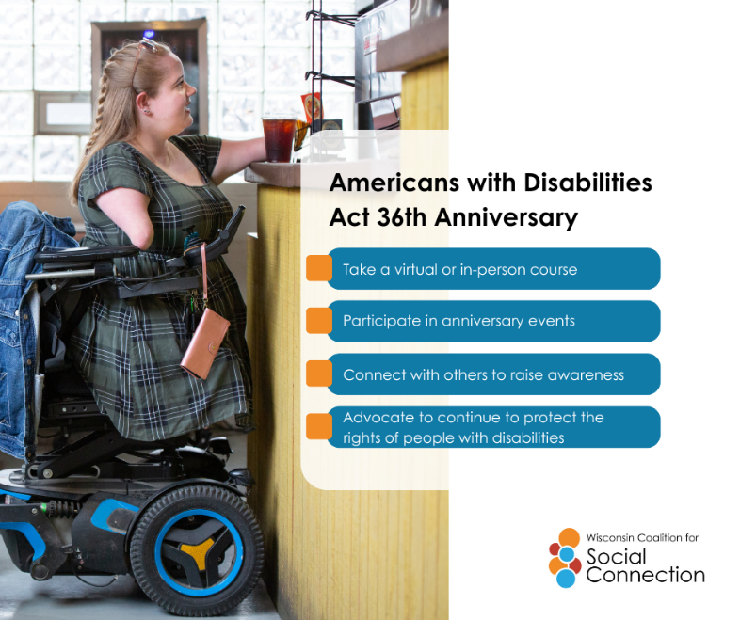 | Today we celebrate the anniversary of the Americans with Disabilities Act (ADA) — a landmark moment in the fight for inclusion, access, and equity. 🎉  The ADA opened doors, literally and figuratively, helping create communities where everyone belongs. But true inclusion means more than access. It means connection.  Let’s continue building a world where people of all abilities can connect, contribute, and thrive — together. Learn more at ADAAnniversary.org. #ADA36  Go to ConnectWI.org to discover more ways to build connection. #ConnectWI #SocialConnection

