EngAged Calendar of Social Engagement Opportunities
National Hispanic  Heritage Month |  | Heritage connects us to where we come from—and to one another.  This National Hispanic Heritage Month, let’s celebrate the vibrant cultures, voices, and traditions of Hispanic and Latino communities while creating opportunities to learn, connect, and build stronger communities together.  Throughout the month, try one of our Social Connection Activities:  - Share Your Story: Tell someone about a family tradition, cultural experience, or person who has influenced you.  - Ask & Listen: Ask someone, “What’s a tradition that is meaningful to you?” and really listen to their answers.  - Learn From Someone: Ask someone about their Hispanic/Latino heritage, traditions, music, food, or celebrations—while allowing them to choose what they’d like to share.  - Share a Favorite: Share a favorite song, recipe, book, movie, or memory that connects you to your culture or community.  Let’s create communities where everyone has opportunities to belong, participate, and share their culture.  Discover more ways to build connection — head to ConnectWI.org. #ConnectWI #SocialConnection
September  13  National Grandparent's Day | 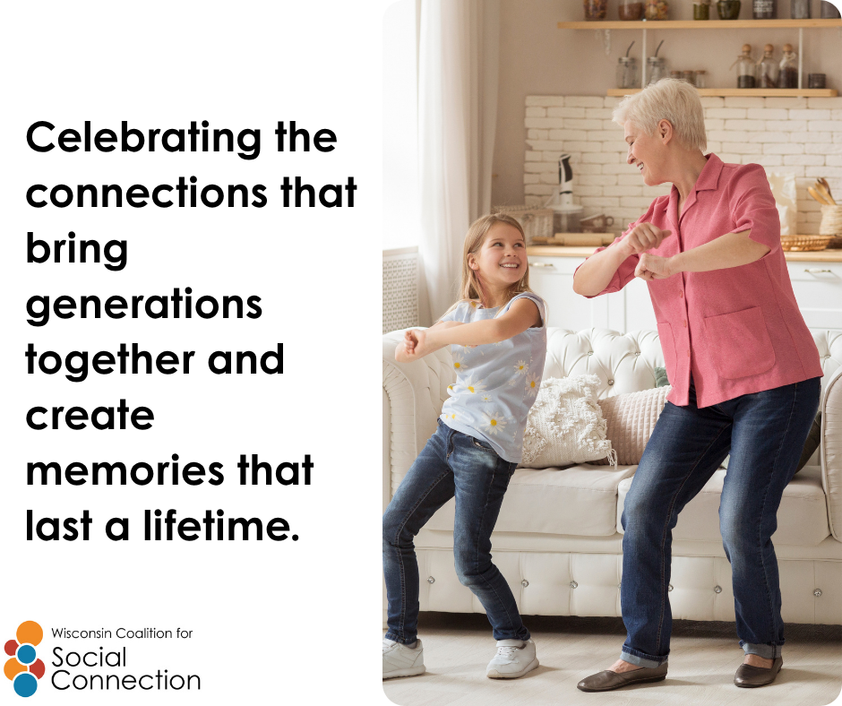 | Today we're celebrating National Grandparent's Day. Today is a wonderful opportunity to celebrate the wisdom, stories, and connections that bring generations together. Whether you’re a grandparent, grandchild, family member, friend, or neighbor, there are many ways to connect across generations.  - Share a favorite family story  - Play a game together  - Make a phone or video call  - Do a simple activity together  - Ask someone about a special memory  Intergenerational connections can happen at any age and in many different ways. Let’s make time to listen, laugh, learn, and share with one another. ️  Discover more ways to build connection — head to ConnectWI.org. #ConnectWI #SocialConnection
September 19  National Dance Day | 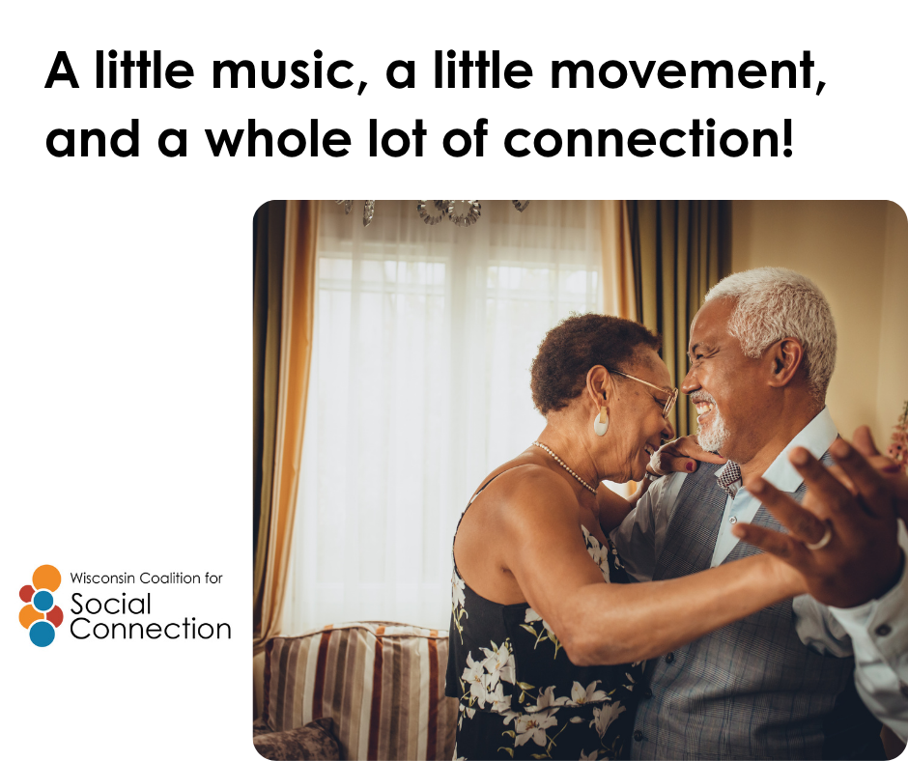 | Happy National Dance Day!  You don’t have to be a professional dancer to enjoy the music and movement! Put on a favorite song and move in whatever way feels comfortable for you. Dance can be standing, seated, with a partner, using your arms, tapping your feet, or simply moving along to the beat.  - Play a favorite song  - Try seated dancing  - Join an inclusive dance class  - Invite a friend to move with you  Most importantly—have fun!  Dance is about more than movement. It can be a joyful way to express yourself, connect with others, and feel part of a community.  What song always makes you want to move?  Discover more ways to build connection — head to ConnectWI.org. #ConnectWI #SocialConnection
September 21  World Alzheimer’s Awareness Day | 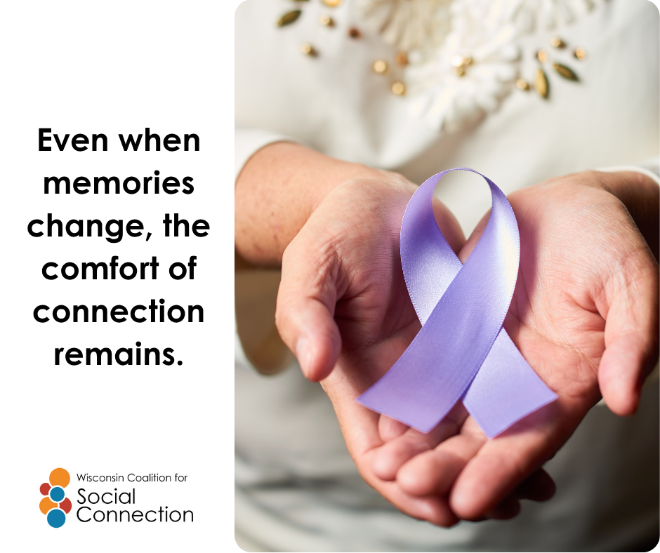 | World Alzheimer’s Awareness Day,  Understanding dementia starts with learning. Some changes in memory and thinking can be a normal part of aging, while other changes may be signs of Alzheimer’s disease or another form of dementia.  Today, take a moment to learn, ask questions, and help create a community where people living with dementia and their families feel welcomed, respected, and included.  - Consider becoming a Dementia Friend. Learn more about dementia and brain health  - Have a conversation with someone who may feel isolated  - Practice patience, understanding, and kindness  Small acts of connection can make a big difference. Everyone deserves to feel seen, valued, and included.  Discover ways to build connection — head to ConnectWI.org. #ConnectWI #SocialConnection
September 28  Good Neighbors Day | 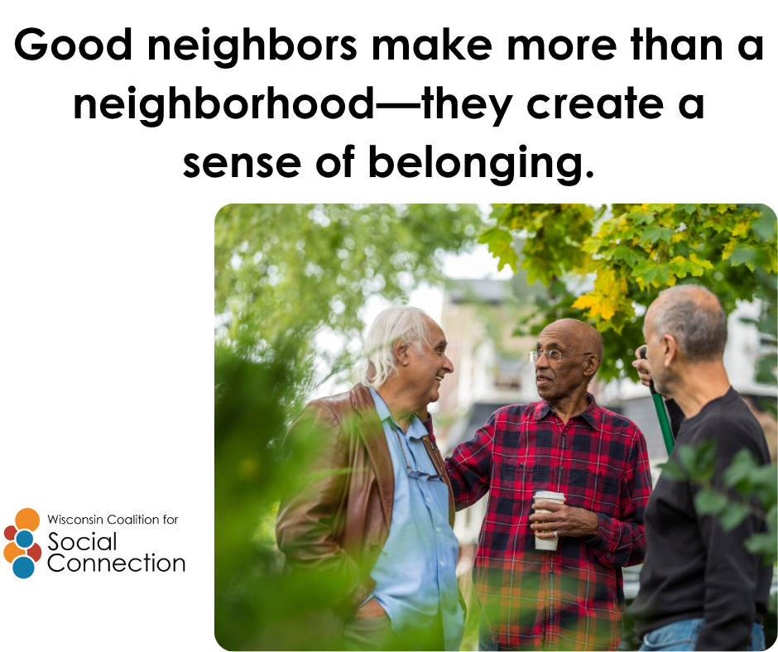 | Good Neighbor Day  A friendly hello can be the beginning of a meaningful connection!  Today, take a moment to reach out to a neighbor. Say hello, introduce yourself, check in on someone, or simply share a smile.  For older adults and people with disabilities, positive connections with neighbors can help create a stronger sense of belonging and community.  - Knock on a door or make a call  - Invite someone to chat  - Share a kind word  - Welcome a new neighbor  - Ask, “How can I help?”  You never know how much a simple conversation might mean to someone.  Let’s build neighborhoods where everyone feels connected, welcomed, and included.  Discover ways to build connection — head to ConnectWI.org. #ConnectWI #SocialConnection

